

School of Mathematics, Computer Science and Engineering

MSc Data Science

Submitted by

Akhil Nallamotu

20208463

Title

Sentiment Analysis of Political Data in Different Countries

Supervised By

Neil Buckley

# Declaration

I, Akhil Nallamotu, declare that this dissertation has been composed solely by myself and that it has not been submitted, in whole or in part, in any previous application for a degree. Except where stated otherwise by reference or acknowledgment, the work presented is entirely my own. I agree that the University may lend or copy this dissertation upon request.

Signature: 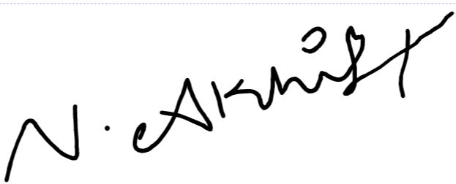       Akhil Nallamotu (12/12/2021)

# Acknowledgements

It’s been a pleasure working with our supervisor Neil Buckley, his guidance, encouragement, and support while working through the project have been a constant force that helped us in completing this project with success. We would also like to extend our gratitude towards a close friend and fellow coursemate Vasanth for constantly providing input and suggestions while working on this project and also helping us optimize the model. Also, we would like to be thankful to the Twitter developer team for accepting the application to provide us with a developer account that helped us accomplish our project.

# Abstract

The increase in the number of users across social media has led to the creation of exabytes worth of data which include images, videos, gifs, music, and also unstructured text which can be in any form from messages to blogs to tweets and posts. All this free flow of information which can be accessed by anyone has created a field of data mining tools that are used by marketing companies to sell better ads and understand the consumer market better, researchers trying to find answers and perform predictions to large scale social media giants using this data to train models which help their platform. One such technique is Sentiment Analysis where you use unstructured or structured data which could be static or in a constant stream from apps like Twitter, to analyze the general opinion of the people or to better understand how people are reacting to a certain event, either positively or negatively. The use of such techniques on political data can give us interesting results like understanding how a person tweets to how the reception of particular tweets has been. One other major area where Political Sentiment Analysis is being used is to predict the election outcomes. In this project, our goal has been to collect such data from Twitter and perform Sentiment Analysis using the Natural Language Processing to analyze each candidate and their political affiliation and see how it changes and then compare it to different countries and see if the analysis change or remain the same.

# Contents

Declaration i

Acknowledgements ii

Abstract iii

Contents iv

Table of Figures vi

1 Introduction 1

1.1 Background 1

1.2 Motivation 1

1.3 Report Structure 2

1.4 Aims 2

1.5 Objectives 3

1.6 Deliverables 3

2 Literature Review 4

2.1 Topic Research 4

2.1.1 Sentiment Analysis of Political Twitter Data from India 4

2.1.2 Sentiment Analysis of Political Twitter Data from the United States 6

2.1.3 Sentiment Analysis of Political Twitter Data from Other Countries 11

2.2 Technical Research 16

2.2.1 Sentiment Analysis using TextBlob 16

2.2.2 Sentiment Analysis using VADAR 19

2.2.3 Sentiment Analysis using BERT 21

3 Design 23

4 Implementation 24

4.1 Importing Tweepy Library to access Twitter API 24

4.2 Pre-processing the Tweets 24

4.3 Ranking Words and Plotting 25

4.4 Assigning Polarity and Subjectivity 27

5 Results 29

5.1 The United Kingdom 29

5.1.1 The Conservative Party 29

5.1.2 The Labour Party 45

5.2 United States of America 61

6.1 Democrats 62

6.2 Republicans 77

6 Conclusion And Future Work 91

6.1 Conclusion 91

6.2 Future Work 92

References 93

# Table of Figures

Figure 1 Emotional analysis of user @vijayrupanibjp 5

Figure 2 Emotional analysis of user @BharatSolankee 5

Figure 3 Wang et al. (2012), architecture for real-time processing Twitter data 6

Figure 4 Wang et al. (2012), Dashboard of positive and negative tweets 7

Figure 5 Ramasubbareddy Somula et al. (2019) sample words from dataset to classify 7

Figure 6 Ramasubbareddy Somula et al. (2019) model predicted results 8

Figure 7 Ramasubbareddy Somula et al. (2019) actual results 8

Figure 8 Ramasubbareddy Somula et al. (2019) correctly predicted states 8

Figure 9 Shah et al. (2021) project workflow 9

Figure 10 Shah et al. (2021) Sentiment analysis results pre and post covid. 10

Figure 11 Shah et al. (2021) Sentiment analysis of 2016 elections 10

Figure 12 Tarek et al. (2016) Outline of the framework 11

Figure 13 Tarek et al. (2016) Evaluation Results 11

Figure 14 Tarek et al. (2016) Time taken to run each algorithm 12

Figure 15 Rill et al. (2014) system framework 13

Figure 16 Rill et al. (2014) Picture of a pre-processed tweet 13

Figure 17 Framework for prediction by Budiharto and Meiliana. 14

Figure 18 Hashtags used to track the presidential election in Indonesia 14

Figure 19 The approach used to define the score for sentiment analysis 15

Figure 20 Sentiment Analysis of presidential candidates based on popular tweets 15

Figure 21 Import statement for TextBlob 16

Figure 22 Assigning the variables to calculate the Polarity and Subjectivity 16

Figure 23 Function to calculate the score 16

Figure 24 Noun - Phase Extraction example 17

Figure 25 Part-of-Speech Tagging Example 17

Figure 26 N-Grams Example 17

Figure 27 Random Arabic text 18

Figure 28 TextBlob used to detect the language 18

Figure 29 TextBlob used to translate the language 18

Figure 30 TextBlob used to translate using auto language detection 18

Figure 31 Initializing the VADAR 19

Figure 32 Assigning the variables for VADAR 19

Figure 33 Assigning parameters for VADAR 19

Figure 34 Plotting the VADAR analysis 20

Figure 35 Pre-training and Fine-Tuning procedure for BERT 21

Figure 36 Difference between BERT and its competition 21

Figure 37 Example summary of BERT Model for Sentiment Classification 22

Figure 38 BERT Token representation 22

Figure 39 Block Diagram of the project 23

Figure 40 Import statement for Tweepy 24

Figure 41 Example of Tokens 24

Figure 42 Tweets of Rand Paul before Pre-processing 25

Figure 43 Tweets of Rand Paul Post-Processing 25

Figure 44 Example of 'Top Words Used' 26

Figure 45 Example of 'Top Organizations Mentioned' 26

Figure 46 Example of 'Top People Mentioned' 27

Figure 47 Tweets with Polarity, Subjectivity, and TextBlob_Analysis attached 27

Figure 48 Example of Total Values counted 28

Figure 49 Example of a plot where Polarity is plotted against Subjectivity 28

Figure 50 Portrait of Boris Johnson 30

Figure 51 Top Words used by Boris Johnson 31

Figure 52 Top People Mentioned by Boris Johnson 31

Figure 53 TextBlob Analysis of Boris Johnson 31

Figure 54 Sentiment Analysis of Boris Johnson 32

Figure 55 Portrait of Dominic Raab 33

Figure 56 Top Words mentioned by Dominic Raab 34

Figure 57 Top Organizations mentioned by Dominic Raab 34

Figure 58 TextBlob Analysis of Dominic Raab 34

Figure 59 Sentiment Analysis of Dominic Raab 35

Figure 60 Portrait of Liz Truss 36

Figure 61 Top Words mentioned by Liz Truss 37

Figure 62 Top Organizations mentioned by Liz Truss 37

Figure 63 TextBlob analysis of Liz Truss 37

Figure 64 Sentiment Analysis of Liz Truss 38

Figure 65 Portrait of Priti Patel 39

Figure 66 Top Words used by Priti Patel 40

Figure 67 Top Organizations mentioned by Priti Patel 40

Figure 68 TextBlob Analysis of Priti Patel 40

Figure 69 Sentiment Analysis of Priti Patel 41

Figure 70 Portrait of Michael Gove 42

Figure 71 Top Words used by Gove 43

Figure 72 Top Organizations used by Gove 43

Figure 73 TextBlob Analysis on Gove 43

Figure 74 Sentiment Analysis on Gove 44

Figure 75 Portrait of Keir Starmer 46

Figure 76 Top Words used by Starmer 47

Figure 77 Top Organizations mentioned by Starmer 47

Figure 78 TextBlob Analysis of Starmer 47

Figure 79 Sentiment Analysis of Starmer 48

Figure 80 Portrait of Andy Burnham 49

Figure 81 Most Common used words by Andy Burnham 50

Figure 82 Most commonly mentioned organizations by Andy 50

Figure 83 TextBlob Analysis of Andy 50

Figure 84 Sentiment Analysis of Andy Burnham 51

Figure 85 Portrait of Sadiq Khan 52

Figure 86 Top Words mentioned by Sadiq Khan 53

Figure 87 Top Organizations mentioned by Sadiq Khan 53

Figure 88 TextBlob Analysis of Sadiq Khan 53

Figure 89 Sentiment Analysis of Sadiq Khan 54

Figure 90 Portrait of Ed Miliband 55

Figure 91 Top Words mentioned by Ed Miliband 56

Figure 92 Top organizations mentioned by Ed Miliband 56

Figure 93 TextBlob analysis for Ed Miliband 56

Figure 94 Sentiment Analysis for Ed Miliband 57

Figure 95 Portrait of Jeremy Corbyn 58

Figure 96 Top Words mentioned by Corbyn 59

Figure 97 Top Organizations mentioned by Corbyn 59

Figure 98 TextBlob Analysis of Corbyn 59

Figure 99 Sentiment Analysis of Corbyn 60

Figure 100 Typical demographic distribution on political parties 61

Figure 101 Portrait of Joe Biden 62

Figure 102 Top Words mentioned by Joe Biden 63

Figure 103 Top Organizations mentioned by Joe Biden 63

Figure 104 TextBlob Analysis on Joe Biden 63

Figure 105 Sentiment Analysis on Joe Biden 64

Figure 106 Portrait of Kamala Harris 65

Figure 107 Top Words mentioned by Harris 66

Figure 108 Top Organizations mentioned by Harris 66

Figure 109 TextBlob Analysis of Harris 66

Figure 110 Sentiment Analysis of Harris 67

Figure 111 Portrait of AOC 68

Figure 112 Top Words used for AOC 69

Figure 113 Top Organizations used for AOC 69

Figure 114 TextBlob Analysis on AOC 69

Figure 115 Sentiment Analysis on AOC 70

Figure 116 Portrait of Bernie Sanders 71

Figure 117 Top Words used by Bernie Sanders 72

Figure 118 Top Organizations used by Bernie Sanders 72

Figure 119 TextBlob Analysis on Bernie Sanders 72

Figure 120 Sentiment Analysis of Bernie Sanders 73

Figure 121 Portrait of Hilary Clinton 74

Figure 122 Top Words used by Hilary 75

Figure 123 Top Organizations used by Hilary 75

Figure 124 TextBlob Analysis for Hilary 75

Figure 125 Sentiment Analysis of Hilary 76

Figure 126 Portrait of Ted Cruz 77

Figure 127 Top Words used by Ted Cruz 78

Figure 128 Top Organizations used for Ted Cruz 78

Figure 129 TextBlob Analysis for Ted Cruz 78

Figure 130 Sentiment Analysis of Ted Cruz 79

Figure 131 Portrait of Lindsey Graham 80

Figure 132 Top Words used by Lindsey 80

Figure 133 Top organizations used by Lindsey 81

Figure 134 TextBlob Analysis of Lindsey 81

Figure 135 Sentiment Analysis of Lindsey 81

Figure 136 Portrait of Mike Pence 82

Figure 137 Top Words mentioned by Mike Pence 83

Figure 138 Top Organizations mentioned by Mike Pence 83

Figure 139 TextBlob Analysis of Mike Pence 83

Figure 140 Sentiment Analysis of Mike Pence 84

Figure 141 Portrait of Marco Rubio 85

Figure 142 Top words used by Marco 86

Figure 143 Top Organizations used for Marco 86

Figure 144 TextBlob analysis of Marco 86

Figure 145 Sentiment Analysis of Marco 87

Figure 146 Portrait of Rand Paul 88

Figure 147 Top Words used by Rand 89

Figure 148 Top Organizations used by Rand 89

Figure 149 TextBlob Analysis of Rand 89

Figure 150 Sentiment Analysis of Rand 90

# 1 Introduction

## 1.1 Background

Sentiment Analysis is one of the use cases of Natural Language Processing (or NLP for short) where one performs contextual mining on the source material which often involves social media sites like Twitter, Reddit, or Facebook, but can also involve other platforms like news outlets, books, blogs and websites (Hussein, 2018). Social media sites like Twitter where topics are discussed by people before they become sensations on other platforms (Rill et al., 2014). All these data provide for an interesting analysis to gauge the public reaction and provide insight into future events like elections (Wang et al., 2012) or current events that cause a huge public response.

## 1.2 Motivation

The main motivation behind this research is to use Twitter data which when writing this paper has over 700 million tweets posted in a day and averages more than 500 million tweets per day since 2013 (Twitter Usage Statistics - Internet Live Stats, 2021) and more often than any other sector, politicians are one of the major sectors where they essentially rely on it to broadcast information to their electorate and constantly advocate their beliefs to their followers and spread agendas (Bernard Enjolras, 2014). Not only politicians, people, in general, take to Twitter to show how they support or reject a particular event, law, or a notion and also use their platform to spread awareness to a particular agenda. Twitter also provides its users an option to directly tweet at someone and have a sense of asking a question directly without revealing their anonymity.

All these constant interactions with each other provide a sense of constant chatter, although most of these can be classified as meaningless banter, some of them can have real-world consequences some of them include campaigns and events like Black Lives Matter, Me Too, Ice Bucket Challenge, He for She and many more. With all this constant supply of data and the recent boom of Political Sentiment Analysis where researchers used Twitter data to predict events like elections in the US 2012 (Wang et al., 2012), Indonesia 2018 (Budiharto and Meiliana, 2018), India 2014(Kartik Singhal et al., 2015) and Egypt 2012 (Elghazaly et al., 2016) to name a few, it begs a question to understand how similar do politicians act in different countries and how differently do they react to events. With twitters native algorithmic bias to amplify right-leaning agendas and political parties than left (BBC, 2021) for what seems to be more interactions as its goal, which Facebook is notorious for doing the same thing time and time again and getting caught (ALEX THOMPSON, 2020), we felt it would be interesting to see how it differs by country to country and by how big of a margin is the difference. Do all the politicians act the same? Or does it depend upon the individual country?

## 1.3 Report Structure

This project will document the whole process that has been done to Design, Implement, document the results, and form a Conclusion about the Political Sentiment Analysis of Twitter data between the United Kingdom and the United States based on their party afflictions and the country as a whole. In this section Chapter 1, we will discuss the aims and the objectives of the project, and the deliverables that could be achieved.

In the Chapter 2 which is Literature Review section we look at previous attempts made by the researchers, this includes examining the different Sentiment Analysis techniques like TextBlob, VADAR, and BERT and also examine research conducted in journals about Sentiment Analysis in general on Political Twitter Data across different countries and understand their aims and outcomes to form a base level of expectation on what can be achieved.

In the Chapter 3 of Design section, we look at the outlook of how the project has been structured by using a block diagram and also understanding the libraries we used and how they are utilized together to get us the analysis we need. In the Chapter 4 of Implementation section we will look at each library we are using like Tweepy to access the Twitter API and extract the tweets from Twitter and more and all the other libraries we used in this project.

In the Chapter 5 of Results section, we will take a look at selected politicians across the United Kingdom and the United States and look at their Twitter data individually and analyze the top words they use to top organizations that have been mentioned to also analyze how positive, negative or neutral their overall tweets have been to also analyze their tweet polarity along with their subjectivity for individuals and also their parties as a whole.

In the Chapter 6 of Conclusion section, we will conclude all our findings, analyze them and find insights and weaknesses of our model, ways in which the whole project can be improved to optimize, and what more we can do to achieve even better results given more resources being available.

## 1.4 Aims

The goal of this study is to use Natural Language Processing (NLP) models to create a sentiment analysis that includes a polarity value that ranges from a scale of -1 to 1 where -1 being the most negative statement and 1 being the most positive statement and also subjectivity of the particular tweet which usually refers to on topic a particular tweet is and how much of the tweet has a personal bias like opinion, emotion and personal judgment (Shubham Jain, 2018). This can be possible by a library known as TextBlob.

The main aim is to use this data and perform other analyses using various python libraries to create many insights on a single politician, his political party and average the results out and observe other political parties in their own country and compare them to similarly aligned political parties around the world and see how they perform.

## 1.5 Objectives

The objectives of our study are as follows:

* Explain how sentiment analysis is used in real-world scenarios and environments
* Observe existing research on Sentiment Analysis Techniques
* Observe existing research on Sentiment Analysis on Political Twitter data from different countries
* Understand how to Design and Implement Political Sentiment Analysis
* Write down the results from the performed Analysis
* Not down the differences and observations between different parties involved and sum them up in a conclusion
* Discuss how you can improve the current model and future work that can be done for better results and improvements.

## 1.6 Deliverables

The following deliverables could be observed by the end of this project:

* Literature review of the Sentiment Analysis Techniques and Sentiment Analysis of Political Twitter data.
* Design a model that extracts the tweets from Twitter of a selected individual and provides us with an analysis of that particular individual.
* A complete overview of the model implementation.
* Through documentation of results from each candidate
* Dissertation Report

# 2 Literature Review

## 2.1 Topic Research

### 2.1.1 Sentiment Analysis of Political Twitter Data from India

As of July 2021, India has over 22 million Twitter users, which is ranked third, with the United States of America and Japan ranking higher (Statista, 2021). Compared to the countries population on 1.2B, 22M might sound like a small number but according to Twitter, they say a YoY growth of 74% which is ranked second highest only bitten by Nigeria with a YoY growth of 84%. All these numbers essentially tell us that more and more people are using this microblogging site to state their opinion and share their views on current topics.

To further cement this point researchers (Kartik Singhal et al., 2015) when conducting sentiment analysis during general elections in 2014 observed that during the time frame of 4 months the conversations about the elections were more than double the total conversations had in 2013 and the more interesting fact in this research was the total number of Twitter users in India doubled during this period. Saraswati in her research states that “Social media essentially turned the election information as a commodity which is often paid by the contestants, viewed and created by voters, and then influenced by the social media experts and influencers” (Saraswati, 2018). To put it simply Social Media essentially becomes a pseudo playground for the politicians to fight their battles.

Karthik et al. (2015) in their research state that adjectives are the main way to identify the sentiment of a statement as a positive or a negative with the adjectives being assigned as a positive adjective or negative adjective, he also added that in recent studies use of verbs and adverbs can significantly affect the opinion someone is trying to make in a statement. The whole way of accessing how subjective a statement involves ranking the words in the dictionary by giving them a polarity score, this type of sentiment-based analysis is called Lexicon Analysis (Kartik Singhal et al., 2015). For his research, Karthik et al. (2015) used Lexicon and Rule-based Sentiment Analysis and used tweets generated on Twitter from 28th February 2014 to 28th March 2014 and used Stanford Dependency Parser (SDP) to set rules for the tweets and remove won’t add any value to the overall sentiment of a particular statement (Kartik Singhal et al., 2015).

Karthik divided the dataset using SDP into seven sets. Set W0 with keywords, W1 with all the verbs, W2 containing all the Object and Subject words, W3 as a Modifier Set with adjectives and adverbs, W4 is the intensifier set with the words that strengthen or weaken the whole statement, W5 will be a buffer set which will include all the conjunctions like “and”, and finally W6 with the negation set which will contain words like “not”, “never” or other negative words. We can observe from the figure below how the algorithm uses these sets to calculate a sentiment score using variables Spre, Sset and Snew.

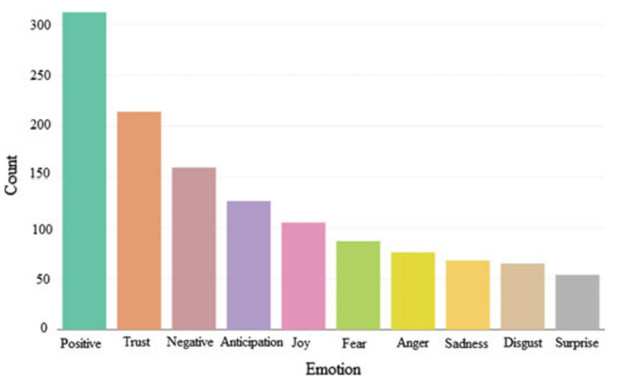

Figure 1 Emotional analysis of user @vijayrupanibjp

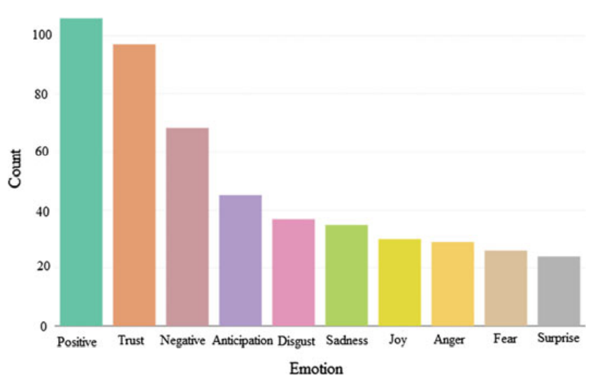

Figure 2 Emotional analysis of user @BharatSolankee

### 2.1.2 Sentiment Analysis of Political Twitter Data from the United States

US election is complicated and confusing, rather than voting for the president, people of the United States vote for representatives, who then meet make their choice on who the next president is going to be. This system is called the electoral college system (Andrew Rudalevige, 2017). Being so complicated makes campaigning much longer than any other country, this usually involves an annual custom of “Presidential Debates” where the incumbent enters into a debate with his challengers, these debates are a television event not only in the US but around the world they provide an endless content of news and entertainment (Richard Thomas et al., 2020), thus adding to the fact that the US has the highest number of Twitter users than any other country (Statista, 2021) makes whole flew of people expressing their opinions on Twitter. In this part let’s observe sentiment analysis was done on US presidential election in 2012 by (Wang et al., 2012), 2016 by (Ramasubbareddy Somula et al., 2019), and the latest 2020 by (Shah and Li, 2021.).

Wang et al. (2012) have amassed more than 36 million tweets since October 12, 2012, about the 2012 general elections which are almost 250K per day, also an interesting thing was during the primary debate which was conducted in Iowa, the team was able to collect more than 500K tweets in just a few hours, this show how important political events like primary debates can be when analyzing political sentiment to make predictions about the outcome of a general election. Because of the scale of data and the ever-increasing supply of tweets, Wang et al. (2012) have composed an architecture for analyzing tweets in real-time and had to use IBM’s InfoSphere Streams Platform(2012), details of the architecture can be found in the figure below. Similar to other researchers' findings, the team found sarcastic tweets the hardest ones to deal with, is they involve negation of what they mean which is just harder for analysis tools to detect or classify (Wang et al., 2012).

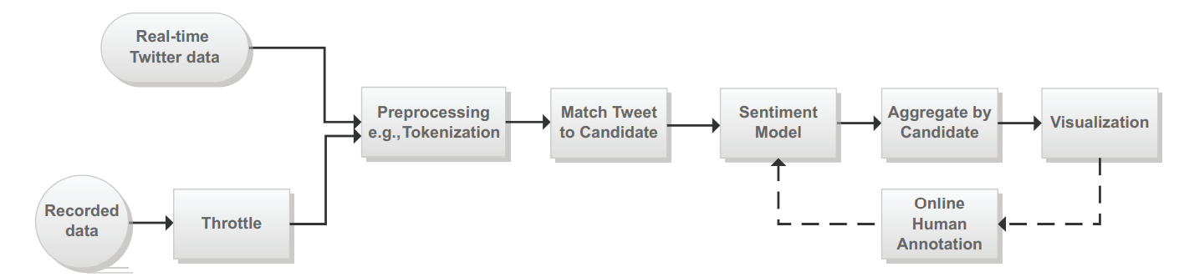

Figure 3 Wang et al. (2012), architecture for real-time processing Twitter data

Because of the limitations set by Twitter API it only lets 1% of the actual traffic will be given to users, this severely limits the analysis which could be overwise been possible, to solve this problem Wang et al. (2012) have used a commercial data providing tool called Gnip Power Track. As the algorithm is primarily going to be used in the political domain, the team has to develop a lot of rules so that repeated data like having multiple names or Twitter handles along with different hashtags couldn’t cloud the whole analysis. Wang et al. (2012) came up with interesting findings where the sentiment of the whole data usually depended on the corresponding event that’s happening in the real life. For example during the state of the union addresses President Obama's total number of positive and negative tweets increased by about 4 times, also during the Republic Primary debate within minutes of asking about Newt Gingrich’s wife the amount of negative sentiment increased rapidly. The total dashboard of analysis done by Wang et al. (2012) can be seen in figure 5 below, it also shows the top positive, negative and neutral tweets.

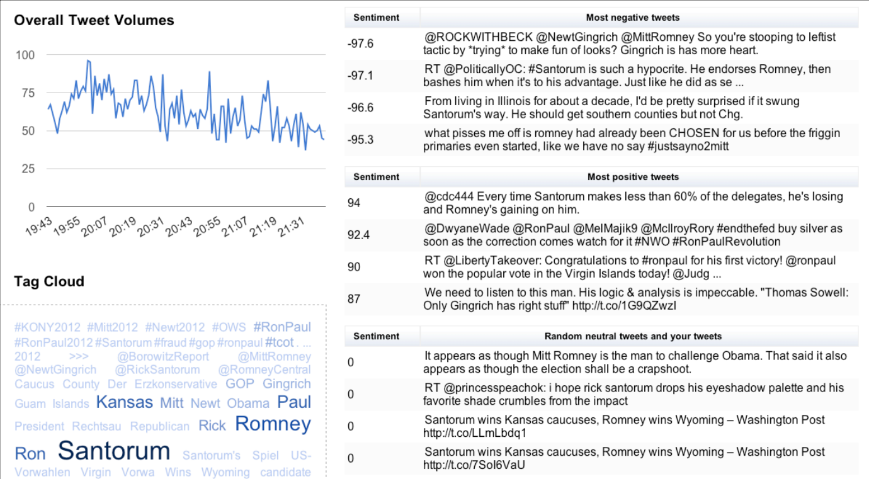

Figure 4 Wang et al. (2012), Dashboard of positive and negative tweets

For their study on the 2016 general elections between Hillary Clinton and Donald J Trump, (Ramasubbareddy Somula et al., 2019) used Twitter data to predict which candidate would win in which state. The performed sentiment analysis using R programming language and the library is known as “twitteR” which allows them to access Twitter API calls, the used the latitude and longitude of tweets to categorize them into which state a particular tweet is referring to. The research team only used the data one day before the actual election which was on November 8th, 2016. The database they created consisted of 100,000 tweets which involved 2000 tweets per state, 1000 for Trump, and 1000 for Hilary. They were able to categorize sample words from the dataset into Positive words and Negative words, the figure is shown below of the dataset. After performing Lexical Analysis when the algorithm can’t assign a sentiment score the team has used this formula to generate an average score based on other tweets and replace the NA values (Ramasubbareddy Somula et al., 2019).

Score = sum(pos.matches) – sum(neg.matches)

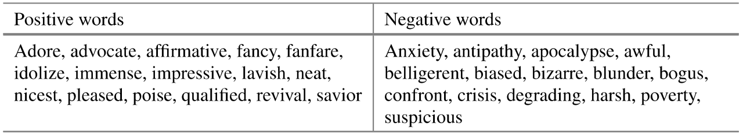

Figure 5 Ramasubbareddy Somula et al. (2019) sample words from dataset to classify

Ramasubbareddy Somula et al. (2019) have assigned three scores (a final score, a positive score, and a negative score) for every tweet in every state. Then they summed all these values and assigned a final score for both Trump and Clinton. Based on the fact who has the higher score the team awarded the state as a victory for them. The interesting thing the team found from their analysis was Clinton had far higher negative scores than Trump and the opposite Trump had far more positive scores than Clinton. This made them predict that Trump would be closer to achieving the 270 electoral seats than Clinton. Based on their final predictions the team was able to correctly predict the results in 31 out of 50 states which gave them an accuracy rating of 62% predicting Trump winning the election (Ramasubbareddy Somula et al., 2019). Given below are the figures that show the predicted result vs actual result.

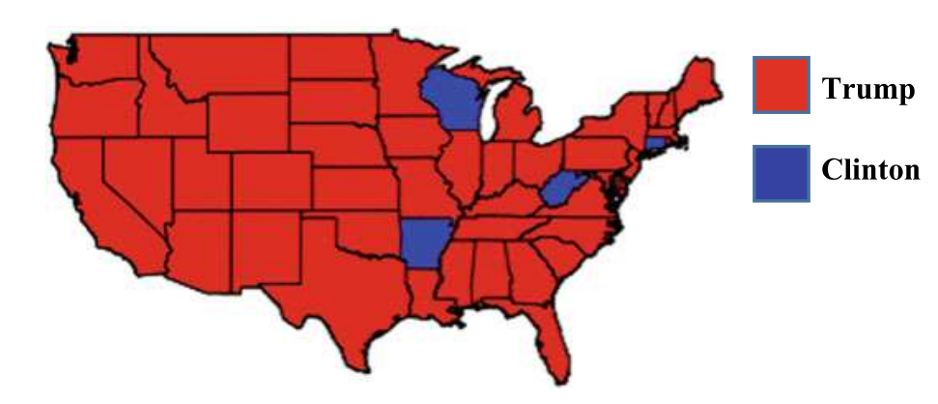

Figure 6 Ramasubbareddy Somula et al. (2019) model predicted results

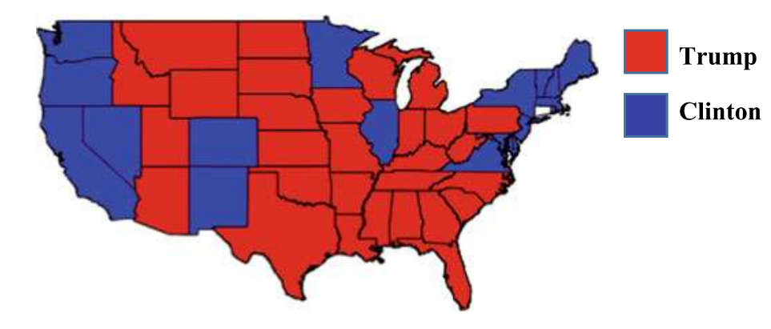

Figure 7 Ramasubbareddy Somula et al. (2019) actual results

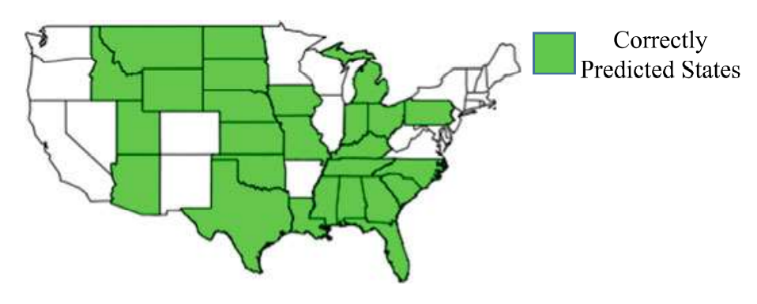

Figure 8 Ramasubbareddy Somula et al. (2019) correctly predicted states

Shah et al. (2021) performed research on the 2020 US general elections and also compared them to 2016 and tried to explain why many models failed to explain Trump winning and how their model was the most accurate of them. Shah et al. (2021) used Long-Short Term Memory(LTSM) algorithm which was based on Recurrent Neural Network to analyze the tweets, they also used VADAR API to label the tweets and achieved an overall accuracy of 93.45% on their test data (Shah and Li,2021.). Research done by Timm et al. (2014) tells you that from the number of people who tweeted 50% of them only tweeted once during the entire 2009 corpus and 90% of all the tweets were tweeted by the remaining 50% users. This doesn’t properly represent the population as the 50% overwhelm the responses (Sprenger et al., 2014).

Shah et al. (2021) for their research collected over 1.25 Million tweets from October 2019 to July 2020 and trained their model with prelabeled tweets provided by Twitter with 55k tweets database and 40K of them being used to training the model and 15K of them being used to testing the model. The figure below shows the proposed workflow of the team. They performed data cleaning by removing the tweets that weren’t in English and any extra details like URLs, @’s, emojis, RTs, hashtags, and other data that doesn’t provide any insight to the sentiment analysis. After the data cleaning stage, the team was left with 1.2 Million tweets out of which a random 55K tweets were taken and labeled using VADAR API and passed through the LSTM algorithm to provide the analysis (Shah and Li, 2021.).

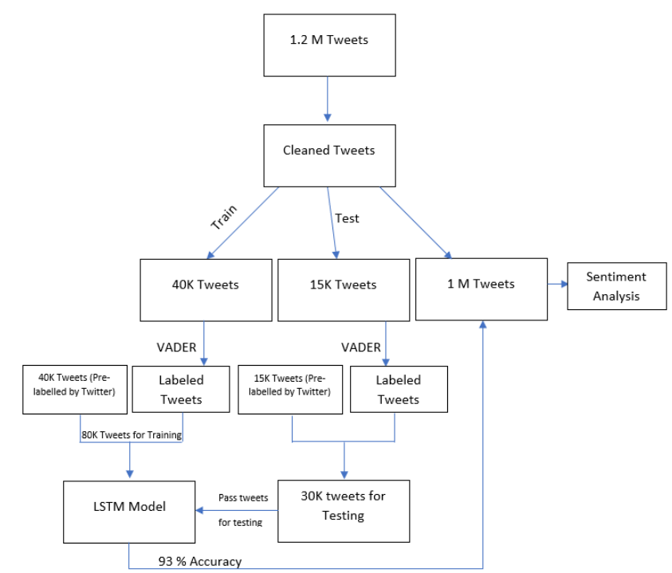

Figure 9 Shah et al. (2021) project workflow

The final results Shah et al. (2021) came up with 59.5% of positive sentiment going to Biden and Trump receiving only 52%. This analysis was done after removing all the neutral tweets. An interesting analysis done by the team was getting tweets from pre covid which were between October 2019 – March 2020 and post covid which were from March 2020 – July 2020. The main difference between these candidates came during this time as Biden was able to increase his positive sentiment from 54.54% to a high 66.67%, while Trump only managed to increase his positive sentiment by just 1%, more details in the figure below. Similarly, they used the same algorithm to analyze the results of the 2016 elections. This election showed Clinton having a higher positive sentiment than Biden at 78.26%. But, in reality, Trump won the elections, Shah et al. explain that this is because even though Clinton won the popular vote, the electoral college still decided to vote for Trump (Shah and Li, 2021.).

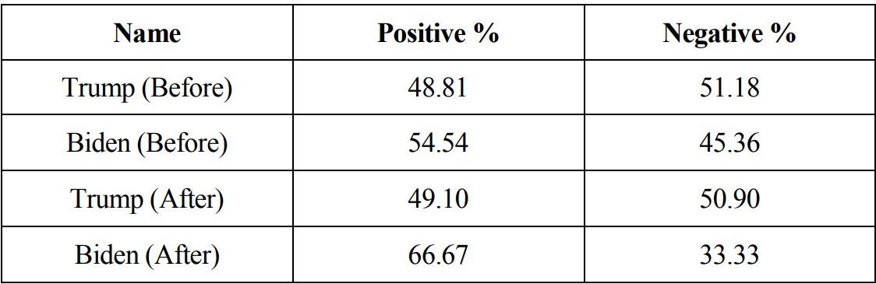

Figure 10 Shah et al. (2021) Sentiment analysis results pre and post covid.

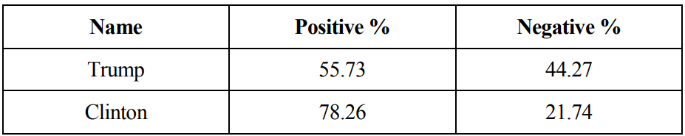

Figure 11 Shah et al. (2021) Sentiment analysis of 2016 elections

### 2.1.3 Sentiment Analysis of Political Twitter Data from Other Countries

Tarek et al. (2016) conducted a study on presidential elections conducted in Egypt in 2012, they compared two major techniques which were used to perform Arabic text classification. The two techniques were Support Vector Machines (SVM) and Naïve Bayesian algorithms. Tarek et al. (2016) explained the complexities that arise when dealing with languages like Arabic, where the language isn’t case-sensitive meaning it doesn’t have any capital words, also Arabic is an inflectional language meaning changing the beginning or end of the word can have dramatically different meaning and grammatical implementations. All these factors make mining harder. For their analysis, the team collected tweets from the 1st of March to the 24th of June in 2012 about the Egyptian Presidential Elections. They were able to collect over 18,000 tweets. The figure given below shows the outline of the framework used to perform analysis (Elghazaly et al., 2016).

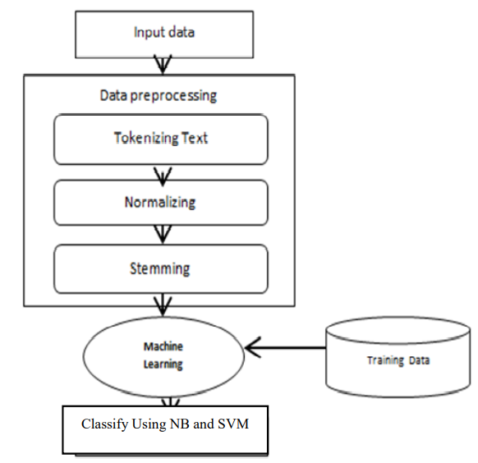

Figure 12 Tarek et al. (2016) Outline of the framework

Based on their tested Tarek et al. (2016) Concluded that Naïve Bayes is more than 5 times faster than Support Vector Machines and also provided better results in all the metrics including Precision, Recall, and F-Measure to classify Arabic text. Complete results can be found in the figure below (Elghazaly et al., 2016).

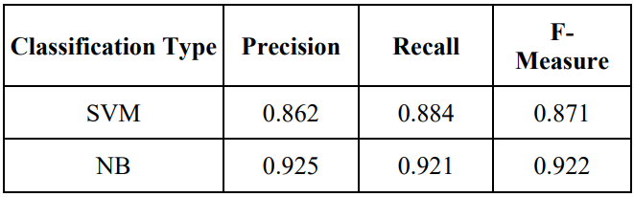

Figure 13 Tarek et al. (2016) Evaluation Results

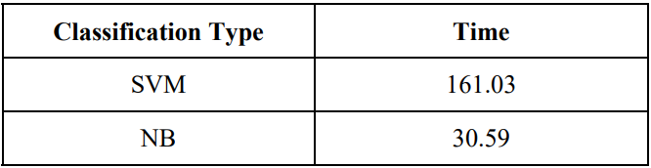

Figure 14 Tarek et al. (2016) Time taken to run each algorithm

Rill et al. (2014) have done an analysis on German parliamentary elections which were conducted in 2013. For their analysis, they have accumulated over 4 million tweets talking about the German elections from April to September of 2013. The interesting thing they discovered while conducting their study was that they performed a similar analysis on google trends data, the results obtained from Twitter were often happening earlier before google trends could pick it up. This shows how powerful platforms like Twitter can be where analysts can know the slight change in public temperature even before other outlets can pick it up. Rill et al. (2014) were able to develop a system where the main goal was to pick up on emerging political topics before they blow up. This research is more to pick up trends in the election rather than a prediction of the election (Rill et al., 2014).

For the data, the Rill et al. (2014) had gathered the data from Twitter using Twitter API and selected the data using a SQL database called Crawler Database. The framework can be found in the figure below. The team used keywords to narrow their search of nine popular parties and the top candidates including “Merkel” and “Steinbruck” and also used synonyms to catch all the tweets which came to about 87 search terms. After defining the search terms the team did pre-processing which involved breaking the tweets down to Hashtags, Sentiment Hashtags, Emotions, and sources for analysis (Rill et al., 2014).

To compare the results they obtained from Twitter they used Google Trends as a base to compare the data. They had to recalibrate the Top Topics to a scale of 0.00 to 1.00, as Google ranks the results and assigns the score between 0.00 to 1.00, it would be easier to compare the results. While they were comparing two topics “Neuland – New Territory” and “Snowden”, they found that in both those instances the topic occurrence in “Topic Values” was many before Google Trends picked it up. Both those search terms had a correlation coefficient greater than 0.67, indicating a high correlation. The team also provides a way to calculate the polarity of the topics so we can gauge the relationship between the polarity and subjectivity(Rill et al., 2014).

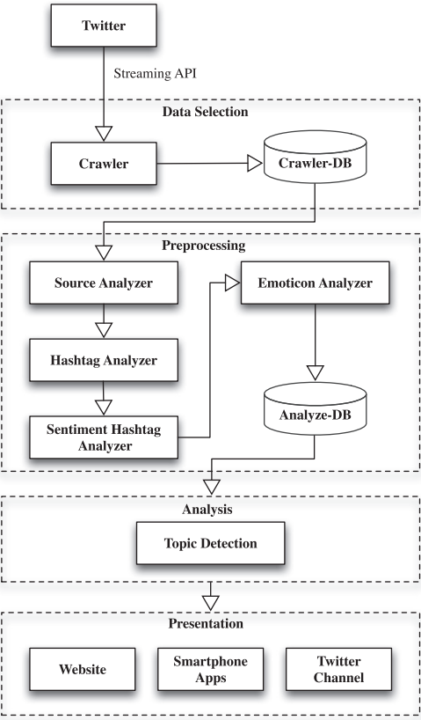

Figure 15 Rill et al. (2014) system framework

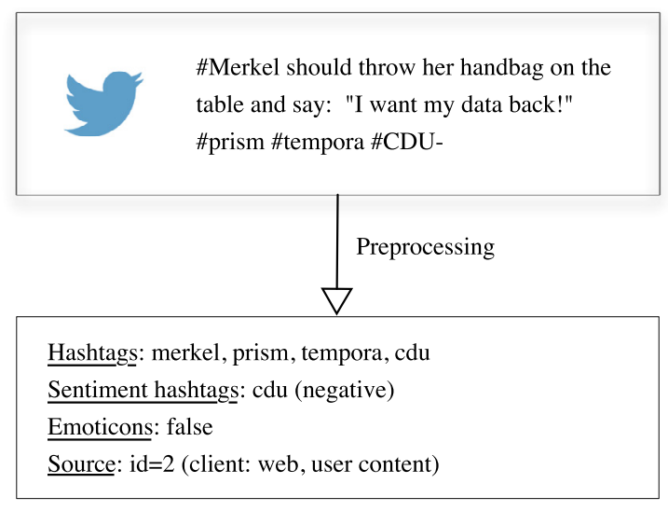

Figure 16 Rill et al. (2014) Picture of a pre-processed tweet

Budiharto et al. (2018) were analyzing the elections conducted in Indonesia in 2019 between the candidates Jokowi and Prabowo. Jokowi is the current president and Prabowo is his challenger and also the person who lost the election to Jokowi in the last presidential election. According to Budiharto et al. (2018) conducting polling analysis using Twitter data when compared to traditional ways of doing polling is much more economical and less time-consuming (Budiharto and Meiliana, 2018).

For implementation, Budiharto et al. (2018) had to get a developer Twitter account to access Twitter API and used OAuth package which was available in R to perform the authentication of their Twitter account and pulled the data about Jokowi and Prabowo and also all the hashtags that were associated with their names and election campaign. Then the authors perform a pre-processing where they remove unnecessary stuff like URLs, Https tags, Hashtags, duplicate tweets, unused letters, etc. Then after filtering the tweets, the team counted the tweets analyzing their metadata like Top Tweets, likes, and retweets, and then they performed sentiment analysis. Details about the framework are in the picture below (Budiharto and Meiliana, 2018).

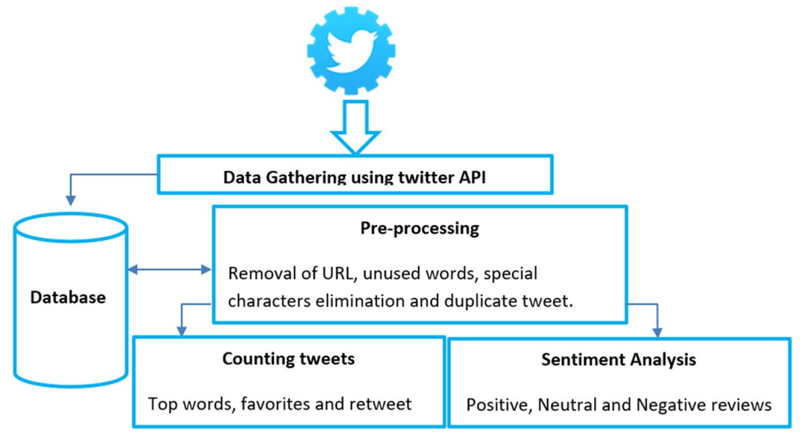

Figure 17 Framework for prediction by Budiharto and Meiliana.

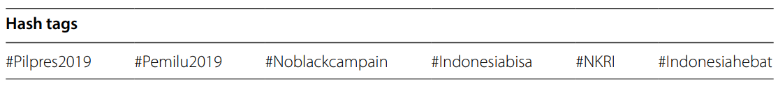

Figure 18 Hashtags used to track the presidential election in Indonesia

So to perform the sentiment analysis the team collected the data for 5 months analyzing the top keywords for both candidates and then calculating the polarity using the TextBlob library. For this, the team had a training set with 250 tweets and a test set of 100 tweets. The author used the following approach to assign a score based on the number of positive words and the number of negative words in a particular tweet (Budiharto and Meiliana, 2018).

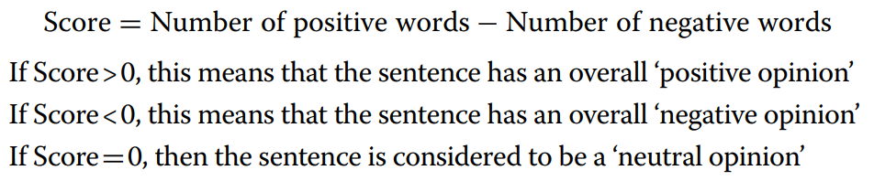

Figure 19 The approach used to define the score for sentiment analysis

After the analysis, the team concluded that even though the method they used for analysis was simple enough and yet it provided quite reliable results in terms of predictions. Throughout their analysis, the team noticed that candidate Jokowi had led throughout the election process and it only kept on increasing as it got closer to the election. The figure below gives us an idea of how the sentiment analysis helped the team make their prediction (Budiharto and Meiliana, 2018).

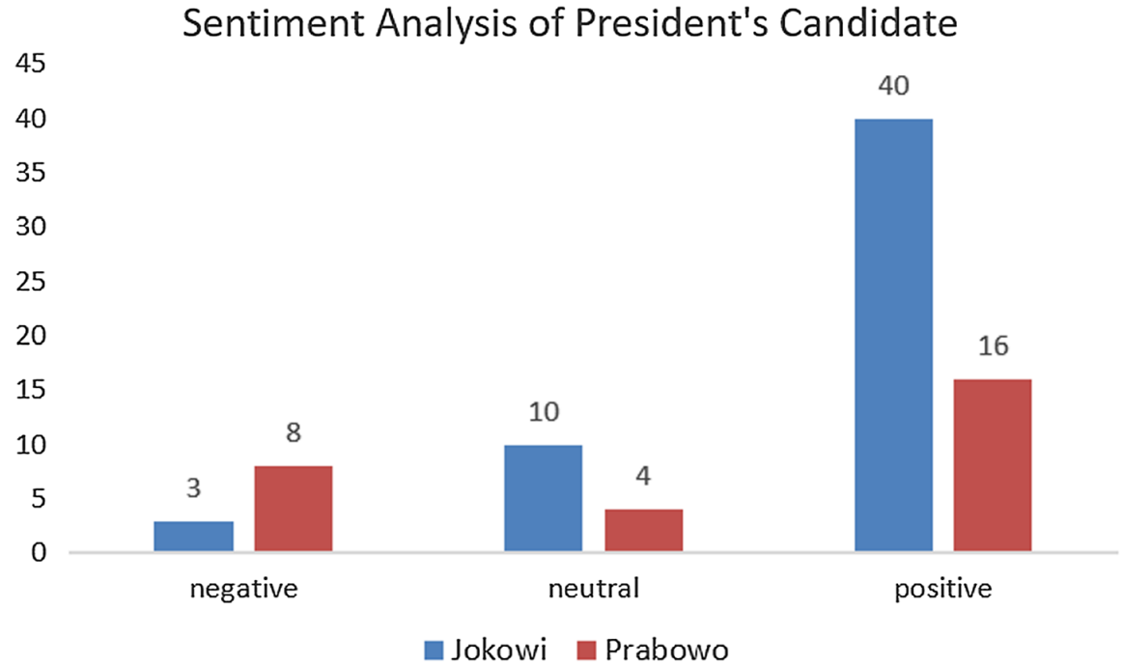

Figure 20 Sentiment Analysis of presidential candidates based on popular tweets

## 2.2 Technical Research

### 2.2.1 Sentiment Analysis using TextBlob

When it comes to performing sentiment analysis TextBlob is the most widely used library to perform Sentiment Analysis. TextBlob uses Natural Language Toolkit or NLTK to perform its task. TextBlob uses a Lexicon-based approach where it allows users to categorize, classify and perform many other lexical tasks. Basically how it works is by having a pre-defined dictionary of classified words and ranked based on how positive or negative a word is. After receiving a sentence the program assigns scores to individual words and calculates the average of all scores and provides us with sentiment analysis (Parthvi Shah, 2020).

TextBlob can also give us a polarity and subjectivity of a particular sentence. Subjectivity tells us the amount of personal judgment and emotions that are involved in a particular sentence, the more subjective the sentence is the more personal opinions it has and less factual it becomes. Subjectivity has a scale of [0-1] and Polarity is on a scale of (-1,1) where -1 is a negative statement and 1 is a positive statement. When we get a score of 0.0 then it’s a perfect subjectivity and perfect polarity and the best result we can hope for (Parthvi Shah, 2020).

Steps to perform Sentiment Analysis using Textblob:

1. Import the TextBlob library using the import statement

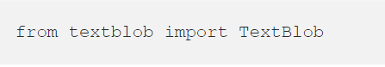

Figure 21 Import statement for TextBlob

1. Then we need to define variables to get polarity and subjectivity scores calculated.



Figure 22 Assigning the variables to calculate the Polarity and Subjectivity

1. Then define a function that will let you assign a score based on the criteria needed.

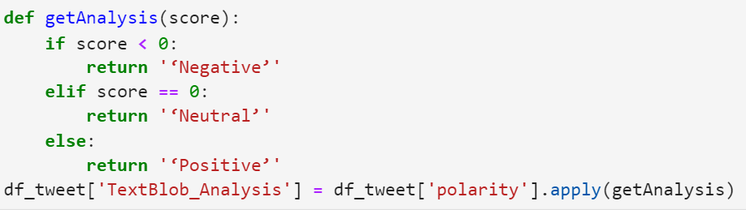

Figure 23 Function to calculate the score

TextBlob can be used to perform many other tasks which are very useful in performing sentiment analysis depending on our situation. One such function we can perform is called “Tokenization”. This is where we essentially break the words down into roughly what they mean. We can perform Noun Phase Extraction where we can analyze who a particular person is in a sentence. This helps us keep track of all the people involved in the conversation. TextBlob has a Part-of-Speech tagging method which essentially is tagging mechanism where you can identify words based on their context or definition. Using TextBlob you can arrange multiple words together based on the parameters set by the user (N > 1) this is called N-grams. Examples of these features can be found in the figures below (Shubham Jain, 2018).

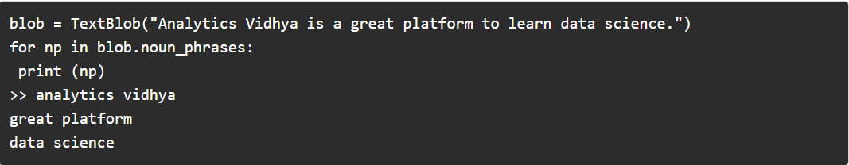

Figure 24 Noun - Phase Extraction example

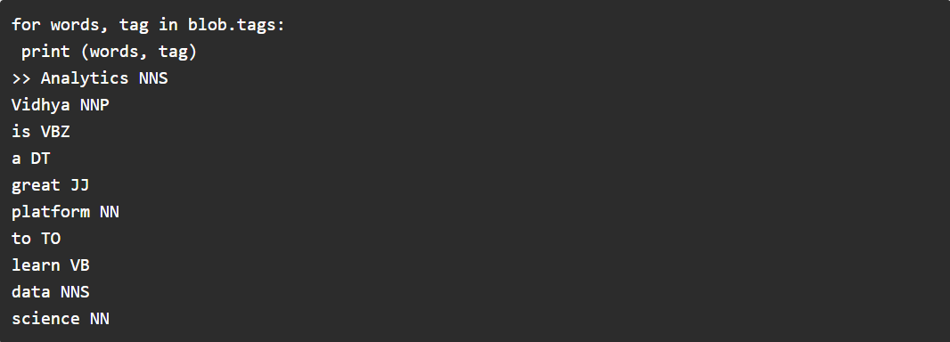

Figure 25 Part-of-Speech Tagging Example

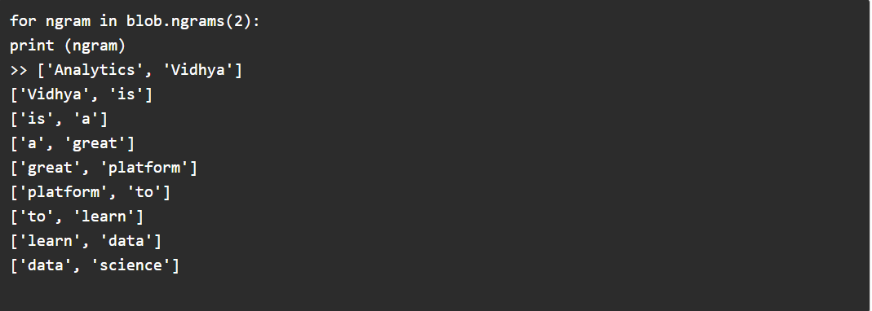

Figure 26 N-Grams Example

TextBlob can perform other cool functions. These are some of them. We can perform spelling correction using the “correct” function which will correct any spelling mistakes that are present in the text. Using “spellcheck()” will give you a list of probable words with their probabilities. TextBlob can be used to detect language using the function “detect_language()”, it identifies the language the text is written in, and also we can use TextBlob to perform translation using the function “translate()”, where we can tell which language you want the text to be translated to or just use the word to and it auto analyses the text and translates it for the required language (Shubham Jain, 2018).

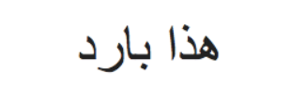

Figure 27 Random Arabic text

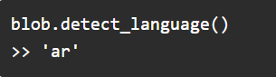

Figure 28 TextBlob used to detect the language

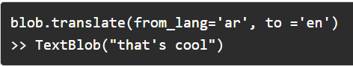

Figure 29 TextBlob used to translate the language

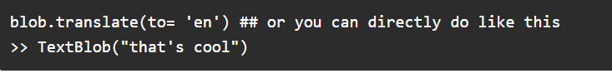

Figure 30 TextBlob used to translate using auto language detection

### 2.2.2 Sentiment Analysis using VADAR

“Valence Aware Dictionary for Sentiment Reasoning” or simply “VADAR” is a rule-based sentiment analysis where it uses a list of lexical features to identify if the given text is positive or negative based on the semantics of the text and then returns with a probability of how positive, negative or neutral a particular text is. The total probability of the positive, negative and neutral probability will always be 100% (Afaf Athar, 2021).

One of the big advantages of VADAR is it doesn’t require any training data. It understands slang better than TextBlob can. VADAR analysis work usually better with social media like Facebook, and Twitter data, it is capable of running in multiple domains (Analytics India, 2020). With VADAR we can also identify how positive or negative sentiment can be. VADAR can also use emojis to perform sentiment analysis and perform classification. VADAR is fast enough that it can also be used online, In fact, Amazon’s Mechanical Turk uses VADAR. Just because VADAR is fast doesn’t mean there’s a performance trade-off. Even with its speed, VADAR can perform very accurately (Bonta et al., 2019).

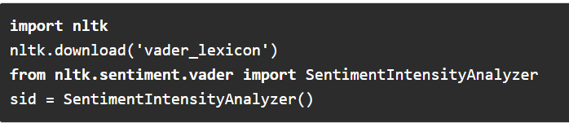

Figure 31 Initializing the VADAR

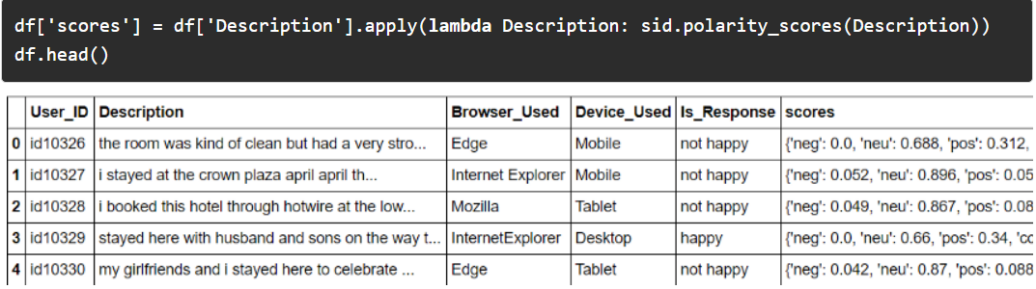

Figure 32 Assigning the variables for VADAR

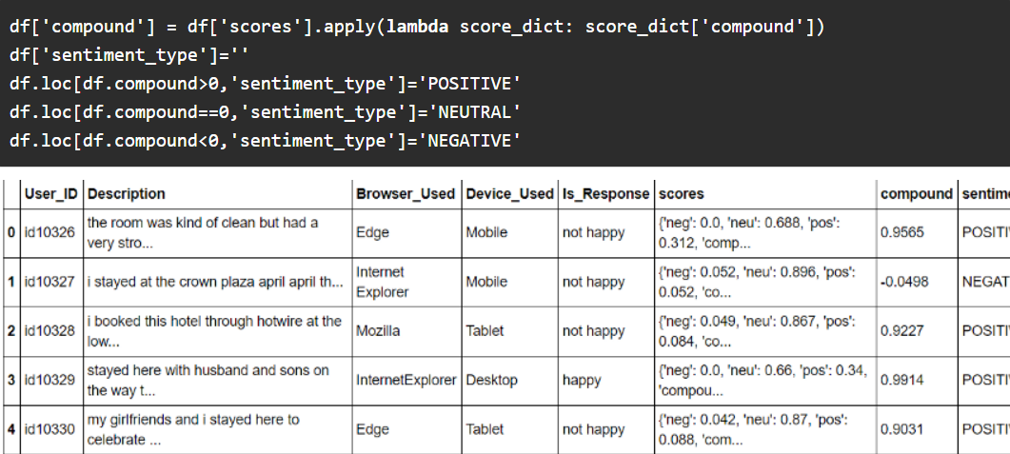

Figure 33 Assigning parameters for VADAR

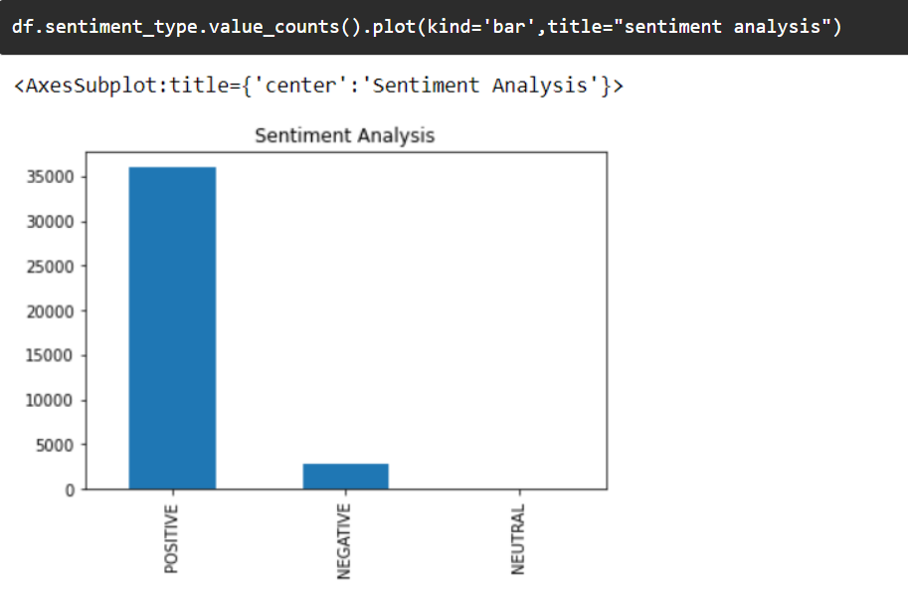

Figure 34 Plotting the VADAR analysis

Method and approach of performing VADAR analysis (Hutto and Gilbert, 2014):

1. Examine all the existing established and validated by human lexicons. (LIWC, ANEW, GI)
2. Supplement the existing lexicons with additional lexical features which are commonly used in social media to express a sentiment like acronyms, slags, and emoticons
3. The “Wisdom of the crowd” approach is to be used to establish point estimations of sentiment valance for all of the 9000+ candidates of lexical features.
4. Keep 7500+ lexical features with certain criteria as human selected gold-standard sentiment lexicon.
5. Use a data-driven iterative approach to perform inductive coding analysis to identify generalizable criteria for assessing the sentiment in the text.
6. Via a controlled experiment evaluate the impact of all the syntactical and grammar rules on the sentiment intensity of text.
7. Ground Truth establishes the point estimates of the sentiment valance on four distinct domains using an aggregate of data from multiple human ratters.
8. Compare the VADAR sentiment analysis to 11 different baseline metrics :
   1. Linguistic Inquiry Word Count (LIWC)
   2. General Inquirer (GI)
   3. Affective Norms for English Words (ANEW)
   4. Liu04
   5. Word-Sense Disambiguation (WSD)
   6. Senti Word Net (SWN)
   7. SenticNet (SCN)
   8. Naïve Bayes(NB)
   9. Maximum Entropy (ME)
   10. Support Vector Machine Classification (SVM-C)
   11. Support Vector Machine Regression (SVM-R)

### 2.2.3 Sentiment Analysis using BERT

Bidirectional Encoder Representations from Transformers or simply called BERT is a bleeding-edge machine learning model which can be used for NLP-related tasks. It is developed at Google by Jacob Devlin in 2018. They developed this model by training it using it on English Wikipedia which has over 2,500 Million words and BooksCorpus with over 800 Million words, this lead to the model achieving the best accuracy possible in 2018. There are two different variants of BERT. One with 12 layers, 768 hidden, 12 heads, and 100 million parameter neural networks while the larger model has over 24 layers with 1024 hidden, 16 heads, and 340 million parameter neural networks to perform NLP tasks (Orhan G. Yalçın, 2020).

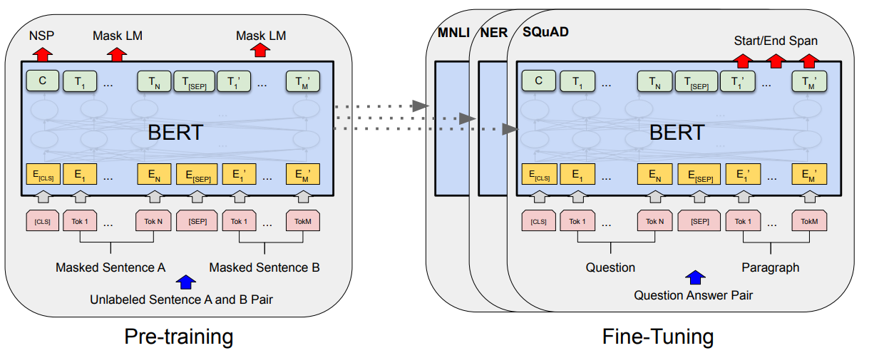

Figure 35 Pre-training and Fine-Tuning procedure for BERT

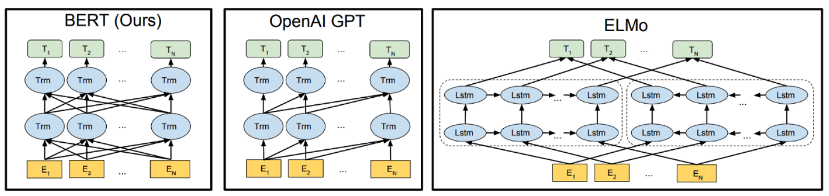

Figure 36 Difference between BERT and its competition

To use BERT we need to have a Transformers library. A transformers library usually has thousands of pre-trained models to perform various tasks on the text like classifications, translation, answering questions, text summarisation, generation of text, extraction of information, etc in over hundreds of languages. The whole point of Transformers is to cutting-edge NLP libraries for everyone to use and develop (Orhan G. Yalçın, 2020).

Steps to install Transformers:

1. Install and import Transformers
2. After installation, we need to load the pre-trained BERT Tokenizer and Sequence Classifier as well as other input-related functions like InputExample and InputFeatures.
3. Then we can use our Sequence Classifier and the tokenizer with the one from BERT’s.
4. And then we can print the summary of our analysis.

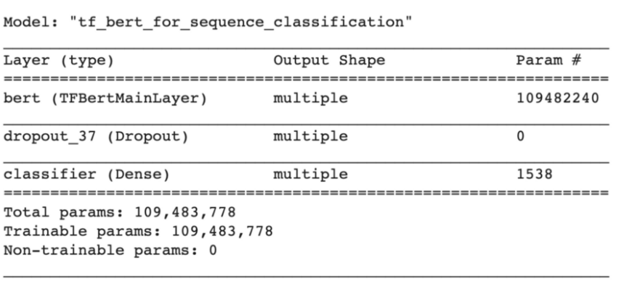

Figure 37 Example summary of BERT Model for Sentiment Classification

While performing BERT analysis tokenization is the most important part of performing BERT analysis. Tokenization is essentially breaking the whole sentence of texts into the sequence of individual words and phrases. This tokenizer essentially can be used to convert the words and phrases it split into an integer sequence. Every single integer value corresponds to the value from the dictionary or the encoding of the entire corpus. There are 3 steps while performing tokenization, they are Token Embedding, Segment Embedding, and Position Embedding. Here’s a picture that describes the whole process.

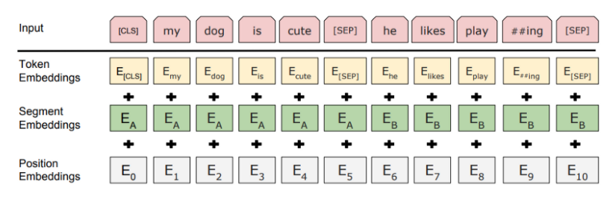

Figure 38 BERT Token representation

# 3 Design

For the particular project, we used ‘Jupyter Lab’ by Anaconda to perform most of the analysis, and some of the analysis was performed by using Microsoft Excel. All of the data that has been used in this project has been acquired from Twitter using their developer program. Here is the block diagram for the whole project.

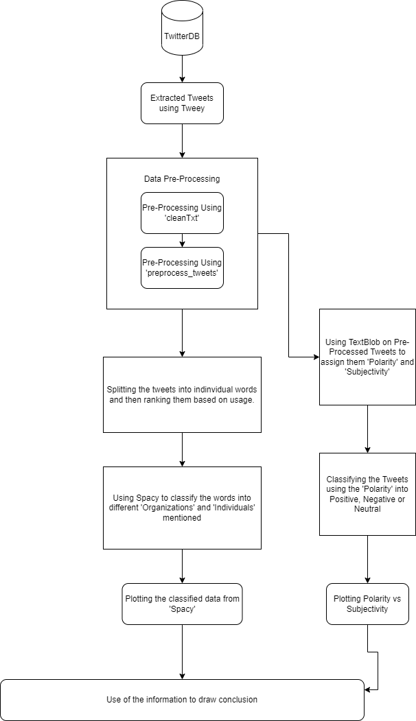

Figure Block Diagram of the project

# 4 Implementation

## 4.1 Importing Tweepy Library to access Twitter API

The main source of data for this project is the tweets of the individuals. To get this data one needs to apply for a Twitter developer account, where one needs to submit details like how is he going to examine the data if it will be used for commercial use or just research use and submit it. Once it gets approved we will then be able to create what are known as tokens. These are what we require to run our project ‘API KEY’, ‘API KEY SECRET’, ‘BEARER TOKEN’, ‘ACCESS TOKEN’, and ‘ACCESS TOKEN SECRET’. These are essentially our credentials for us to access the Twitter data frame using Tweepy API. So what Tweepy library does is it lets us connect to the Twitter data frame, lets us authenticate our account, gives us multiple filter parameters which we can use to search for particular hashtags or usernames or particular criteria. We need to import this module using the following import statement.

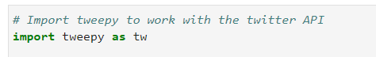

Figure Import statement for Tweepy

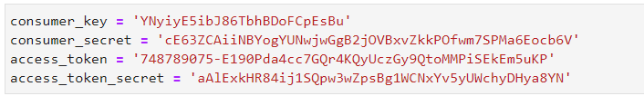

Figure Example of Tokens

## 4.2 Pre-processing the Tweets

Tweets directly extracted from Twitter have a lot of extra information which isn’t useful for our analysis and can cause misleading results for the project. The first stage of the pre-processing can be performed by using a user-defined function called ‘CleanText’, what this function does is uses regular expressions to find and remove metadata in tweets like ‘RTs’ – Retweets, ‘Https’ – Links, ‘#’ – Hashtags, ‘&’ – And, ‘amps’ – And percent’s, and ‘:’ – colons. Once we run the first stage of pre-processing we are still left with tweets that can be even further processed. Here we can use custom stopwords which essentially gives us access to a special list of words where we can add more which we would like to exclude from our analysis. Then we run pre-processing again this time removing the stopwords and also trying to discard all the non-English analysis as that’s the main language we used to perform analysis and also perform lemmatization where we try to extract a group of words together or variants of the same word and show it as the single root word. These actions are performed by the user-defined function ‘preprocess_tweets’. We can see a short glimpse of tweets before pre-processing and after pre-processing below.

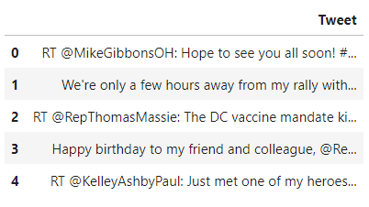

Figure Tweets of Rand Paul before Pre-processing

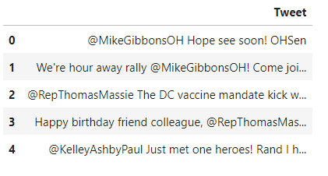

Figure Tweets of Rand Paul Post-Processing

## 4.3 Ranking Words and Plotting

Now after we process the tweets we need to split them into individual words and then rank them based on the number of times they have been used. We can achieve this by first converting all of our tweets into a string and then splitting them into individual words where we split using the criteria of spaces and then use a function to append them to a list and update them using counters and again using the stopwords to again filter the list so that they didn’t creep up during the 2nd pre-processing stage. We then use Pyplot from matplotlib to plot the top 10 words used on a bar plot. Here we also use a library called ‘Spacy’ which can then help us find the top organizations a particular candidate is mentioning by using context in the words and it can also help us identify how often the particular candidate mentions different individuals. We use split and plot them the same way we organized and plotted ‘Top Words Mentioned’. Here is an example of the graphs.

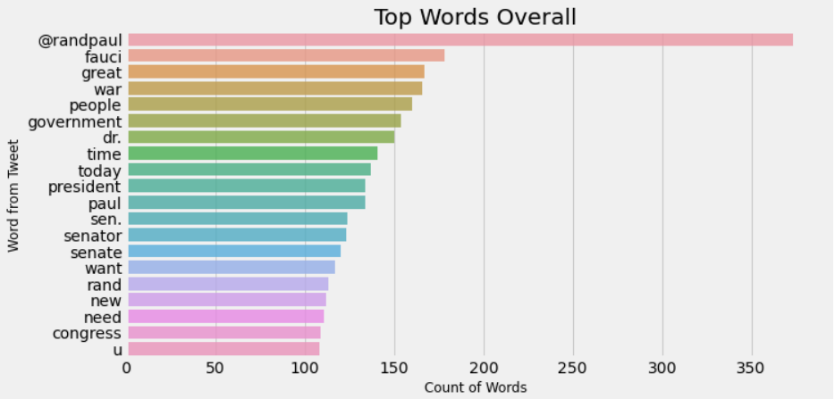

Figure Example of 'Top Words Used'

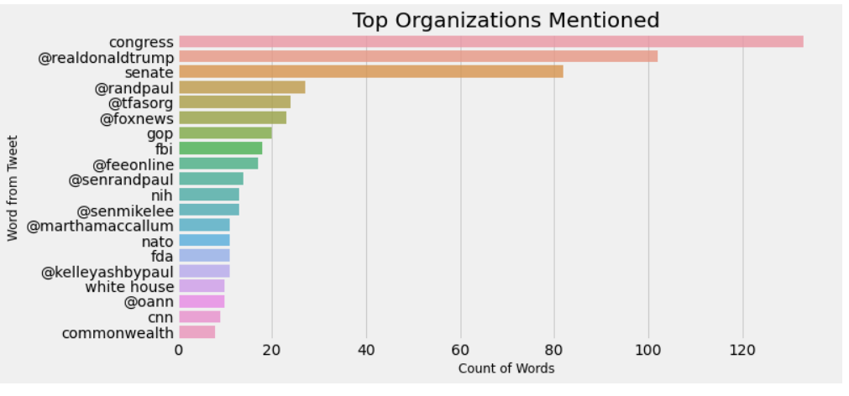

Figure Example of 'Top Organizations Mentioned'

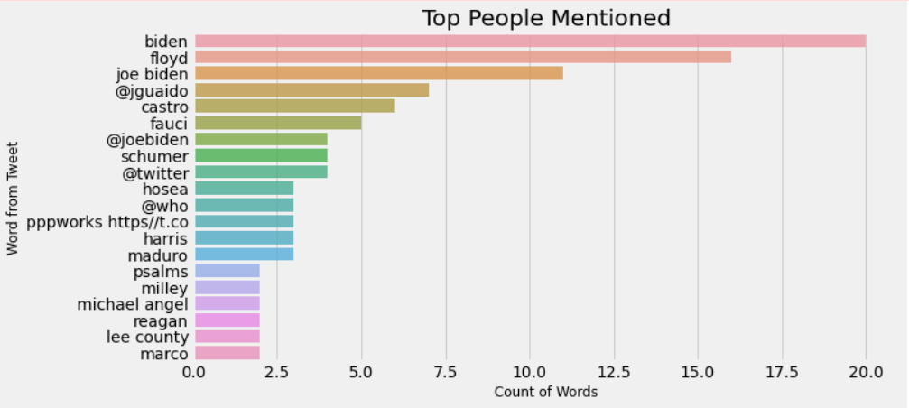

Figure Example of 'Top People Mentioned'

## 4.4 Assigning Polarity and Subjectivity

To get the Polarity and Subjectivity of an individual tweet we need to go to the initial pre-processed database and then use library ‘TextBlob’ to assign each tweet a polarity score and subjectivity score. We then design a function that essentially takes every tweet and then checks its polarity value and assigns the tweet to ‘Negative’ if the value is less than zero, ‘Neutral’ if the value is zero and then ‘Positive’ if the tweet has a positive value which is more than zero. We then take all these values and then assign them to our database. We can then use ‘.value_count()’ function to get the total count of ‘Positive’, ‘Negative’, and ‘Neutral’ tweets, we also use the ‘mean()’ function to get the average polarity and subjectivity value. We can then use ‘Pyplot’ to map the polarity vs the subjectivity of an individual.

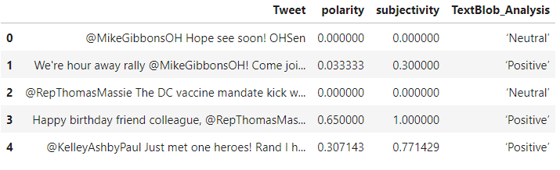

Figure Tweets with Polarity, Subjectivity, and TextBlob_Analysis attached

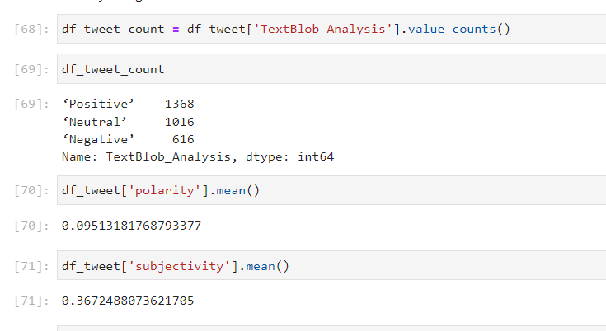

Figure Example of Total Values counted

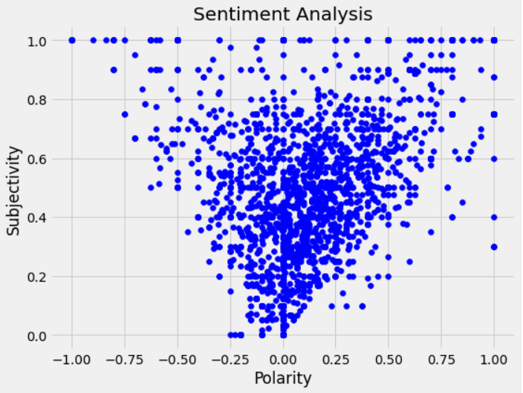

Figure Example of a plot where Polarity is plotted against Subjectivity

# 5 Results

## 5.1 The United Kingdom

British politics work in a different way than many other countries, this is partly because even though they have a monarch (The Queen) they are also a functioning democracy. The Queen (Queen Elizabeth II) even though is the head of the state, is not the one who is head of the government. Most of the decisions are made by the ruling government which is led by the Prime Minister, or PM. This is because of the Magna Carta or the Great Charter which removed the absolute power from the monarch (then King John of London) in 1215 which was followed by “The Bill of Rights” in 1969, which laid out how the powers of Parliament will limit the power of the Crown which made the role of crown ceremonial (GBMag, 2021).

England is the biggest and most powerful block in the union of the four countries (England, Scotland, Wales, and Northern Ireland). Although all the countries in its union have their governments and rules, the parliament still has the higher say in many crucial sovereign issues like trade, military, immigration, laws, majority spending, and many other important factors.

There are five major parties in the United Kingdom. The Conservatives, The Labours, The Lib Dems, The Green Party, and The Brexit Party. Right now The Conservatives control the house and are led by Boris Johnson as their leader and Prime Minister of the United Kingdom.

### 5.1.1 The Conservative Party

The Conservative Party or simply called Tories are often referred to as the Right Wing as their policies and laws try to swing in towards the right side of the political spectrum. They usually promote owning private properties, less government interference, fewer regulations for businesses, preservation of the history, values, and institutions, and finally, everyone should look after their attitude. The first-ever Conservative Government was formed by Sir Robert Peel in 1834 based on the promises of proper taxation, improvements on law and order, better laws against abuses, and better trade(Paul David Webb, 2021).

Some of the prominent leaders like Winston Churchill, Edward Heath, and Margaret Thatcher of the United Kingdom have come from the Conservative Party. The last decade and through most of the time this has been the ruling party for the United Kingdom and is the main force behind shaping the UK as we know it. They were the party who led the UK during the World War, through historical decisions like joining EEA and also leaving the European Union (aka Brexit).

Here is the Sentiment Analysis of some of the members of The Conservative Party.

#### Boris Johnson

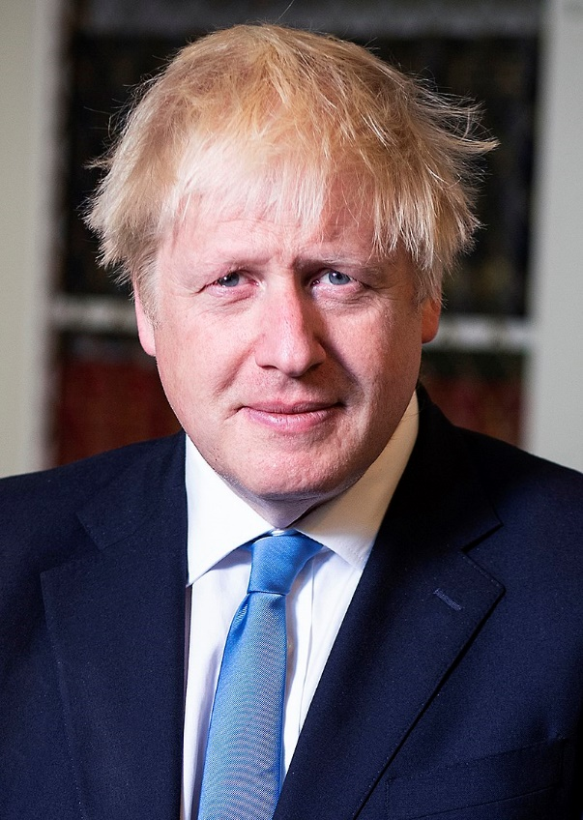

Figure 50 Portrait of Boris Johnson

Alexander Boris de Pfeffel Johnson also known as Boris Johnson is the current Prime Minister of the United Kingdom, He is preceded by Theresa May in 2019. After which he won the General Elections and formed a Government in late 2019. He was the one responsible to negotiate the Brexit Deal, and leading the UK through a COVID 19 pandemic. He is being labeled as the government that does whatever it wants and labels it as “What Works”. He is also called to have little respect for checks and balances and on executive power. Many claims that the policies be brings he would denounce if he was in the opposition (Financial Times, 2021).

Boris was born in 1964 in New York City and until a few years ago held Dual Citizenship. Boris has always been part of an elite group with his education being done at prestigious Eton College. He has been a right-wing politician throughout his life with his column in The Daily Telegraph where he had a strong community of Eurosceptic people. From his vast political experience, he was also the mayor of London from 2008 – 2016.

From the figure, we can see that even after Brexit, it’s still one of the most talked-about issues by Boris Johnson and we can see issues like NHS being talked about a lot. The other interesting thing to note is that Boris Johnson talks about COP26 a lot which was a big event that took place in Glasgow, where all the world leaders meet to discuss the current issues impacting the environment. From our analysis we can see that over 3000 tweets can see that there are over 1794 tweets are Positive, 905 are Neutral and 301 are Negative, which gives us a 59.8 % positive, 30.16% neutral, and 10.03% negative. Boris Johnson had a polarity of 0.1610964 and subjectivity of 0.3984366, given below is a figure of his polarity plotted against his subjectivity.

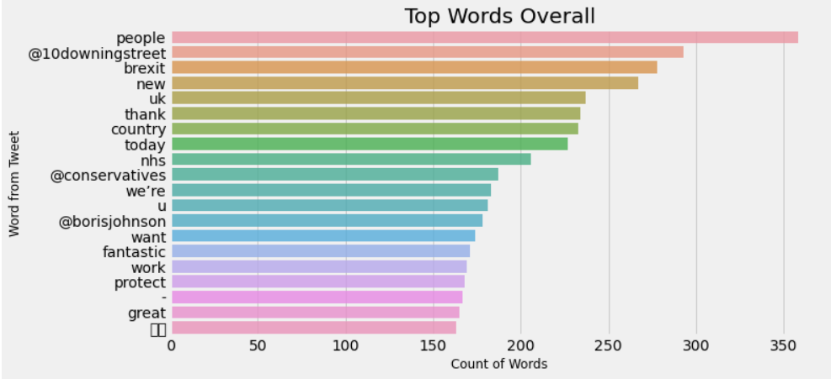

Figure 51 Top Words used by Boris Johnson

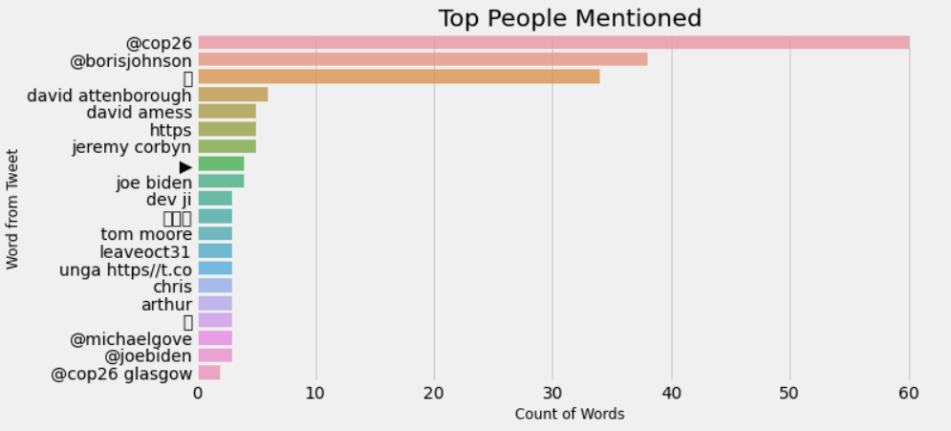

Figure 52 Top People Mentioned by Boris Johnson

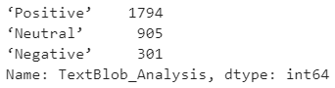

Figure 53 TextBlob Analysis of Boris Johnson

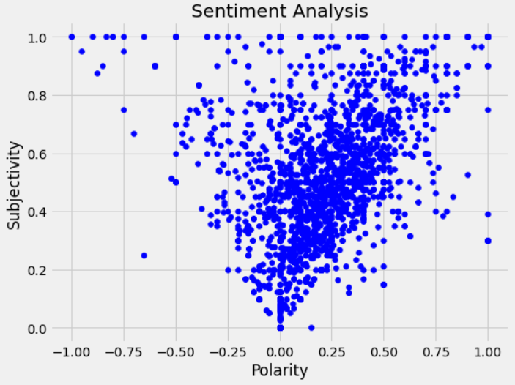

Figure 54 Sentiment Analysis of Boris Johnson

#### Dominic Raab



Figure 55 Portrait of Dominic Raab

Dominic Rennie Raab is also known as Dominic Raab is the Deputy Prime Minister, Lord Chancellor, and Secretary of State for Justice since 2021 (Gov.UK, 2021a). He has been elected as a Member of Parliament from the constituency of Ester and Walton ever since he was first elected in 2010. Before assuming current roles Raab has served as a Secretary for Brexit in 2018 and First Secretary of State and Foreign Secretary from the start of 2019 to 2021.

Raab was born on 25th February 1974 in Buckinghamshire county. Raab studied law at Oxford in Lady Margaret Hall and proceeded to do his Masters of Law at Jesus College at Cambridge, where he won Clive Parry Academic Price for International Law. Before joining Foreign Office in 2000, Raad worked at a multinational law firm called Linklaters for two years to fill his contractual obligations.

From the tweets, we gathered the most used word has been “UK” with over 800-word count and other words having high word count include “today”, “support”, “new”, “global” and “foreign”. When we look at all the people he mentioned we can see that he mentioned Boris Johnson the most with over 160 mentions, then comes his own office which he mentioned over 70 times followed by Foreign Office. From our TextBlob analysis we can see that 1822 tweets were Positive, 677 were Neutral and 501 were Negative, giving them a 60.7% positive rating, 16.7% negative rating, and 22.56% neutral. Raab’s tweets had a polarity of 0.1434508 and subjectivity of 0.3822224. From the figure below we can see the polarity plotted against subjectivity.

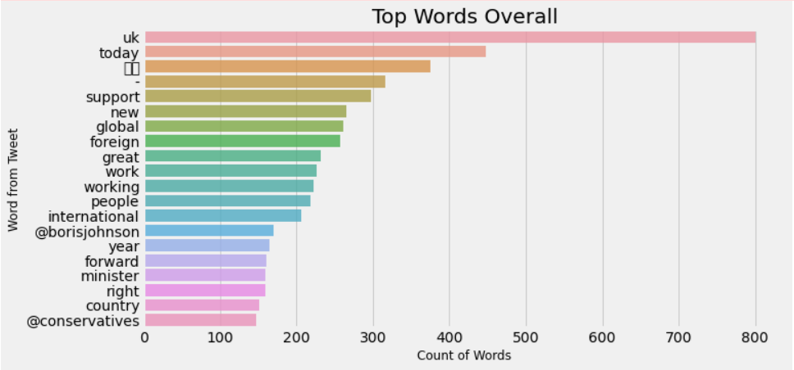

Figure 56 Top Words mentioned by Dominic Raab

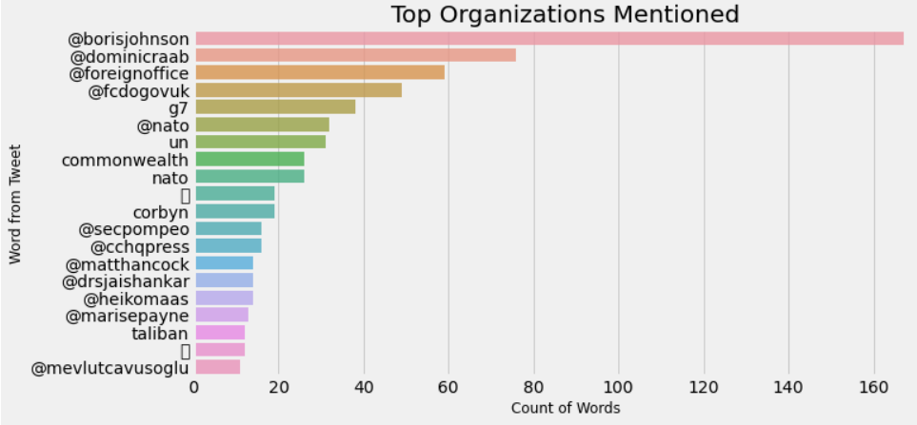

Figure 57 Top Organizations mentioned by Dominic Raab

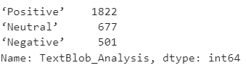

Figure 58 TextBlob Analysis of Dominic Raab

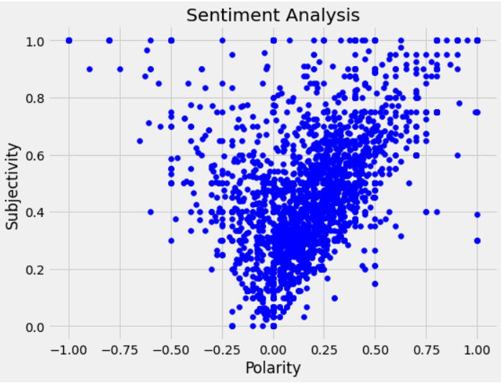

Figure 59 Sentiment Analysis of Dominic Raab

#### Elizabeth Truss

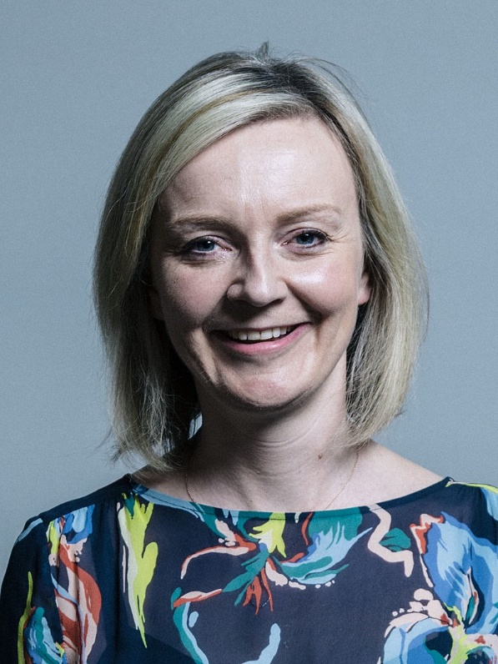

Figure 60 Portrait of Liz Truss

Elizabeth Mary Truss also known as Liz Truss is the Secretary of State for Foreign Affairs, as well as for Commonwealth and Development Affairs since 15th September 2021 and she is also the Minister for Women and Equalities since 10th September 2019. She has been elected as a Member of Parliament from the constituency of South West Norfolk, since 2010. Liz’s political career include being served as Secretary of State for Education and Childcare in 2012, Secretary for Education, Food and Rural Affairs beginning in July 2014 until July 2016, Liz also had a brief stint where she was Secretary for Justice from 2016 to 2017 then Chief Secretary of Treasury from June 2017 to July 2018 (Gov.UK, 2021b).

Liz was born on 26th July 1975 in Oxford. Truss received her early education in Scotland and later she studied Philosophy, Politics, and Economics in Oxford at Merton College. Truss worked for Shell as a commercial manager after graduating from Oxford in 1996, and then worked as an economic director at Cable and Wireless, her last job before joining the politics was as a Deputy Director at Reform in 2008. She has been called “To the left of Labour” (Gov.UK, 2021b)

Based on the tweets we gathered, we can observe that “trade” is the word which has been used the most, this is explained as Truss is a Secretary of State for Foreign Affairs and trade is an important aspect of Foreign Affairs. We can also see other words like “UK”, “New”, “Great” and “Deal” being at the top. The TextBlob analysis shows us that Truss had over 2012 positive tweets, 776 were neutral and 212 are negative tweets, which gives us a positive rating of 67%, negative rating of 7%, and neutral rating of 25%. Truss’s tweets had a polarity of 0.2162292 and subjectivity of 0.4090638494, here is the graph plotted of polarity vs subjectivity.

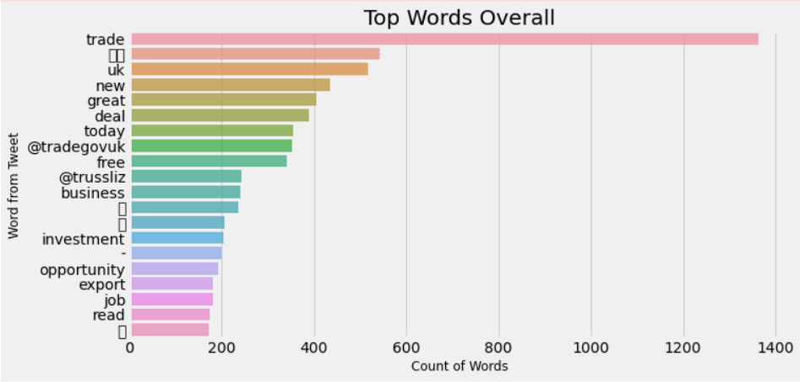

Figure 61 Top Words mentioned by Liz Truss

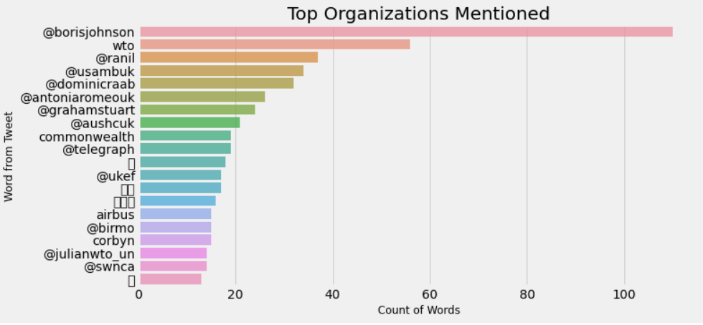

Figure 62 Top Organizations mentioned by Liz Truss

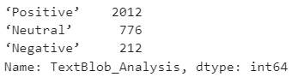

Figure 63 TextBlob analysis of Liz Truss

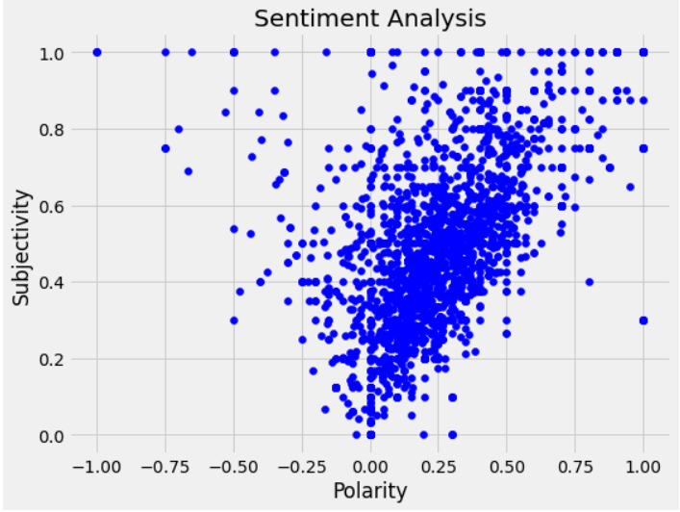

Figure 64 Sentiment Analysis of Liz Truss

#### Priti Patel

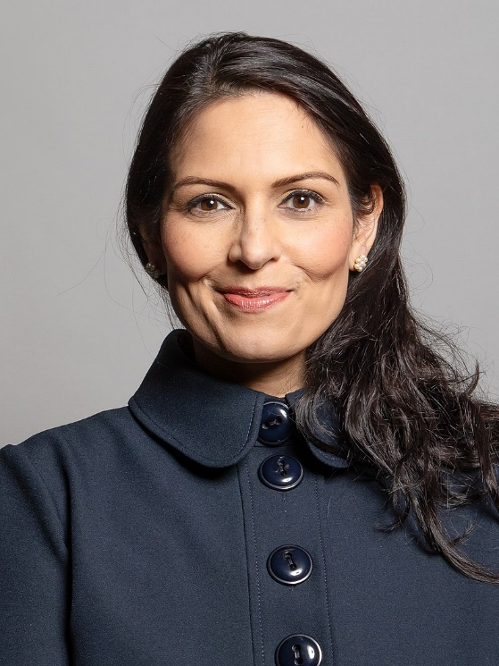

Figure 65 Portrait of Priti Patel

Priti Sushil Patel also better known as Priti Patel is the Secretary of State for the Home Department from 24th July 2019. She has been elected as a Member of Parliament for the constituency of Witham from May 2010. Before taking the current position Priti Patel served many other roles like Secretary for International Development between 2016 – 2017, Minister for Employment between 2015 – 2016, and Secretary of Treasury between 2014-2015 (Gov.UK, 2021c).

Priti Patel was born on 29th March 1972 in London. Patel studied most of her primary education from Hertfordshire, then proceeded to get a degree in economics at Keele University and then achieved a Masters's Degree in British Government at the University of Essex. After finishing her education at Essex Patel joined Conservative Central Office as an intern from then she had a short stint with a Eurosceptic party known as Referendum Party before joining back into the Conservative party in 1997 where she has been ever since.

Based on the tweets we gathered we can see that the word police (count over 350) is being used more than any other word, this can be explained as Patel is a Secretary of the Home Office and her job involves protecting the nation with includes the police. We can also see that words like new, people, officer, being used very often. From the TextBlob analysis we can see that there are 1627 positive tweets, 803 neutral tweets, and 570 negative tweets, giving them 54% Positive, 19% Negative, and 26% Neutral tweet ratings. The subjectivity of her tweets is 0.416727 and the polarity of her tweets is 0.12108323. We can observe her Polarity plotted against her Subjectivity in the figure below.

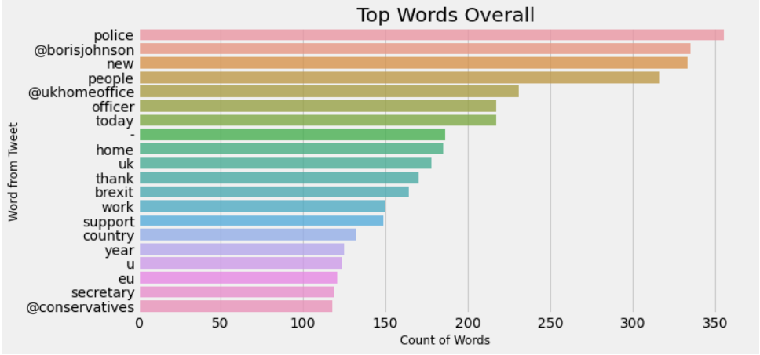

Figure 66 Top Words used by Priti Patel

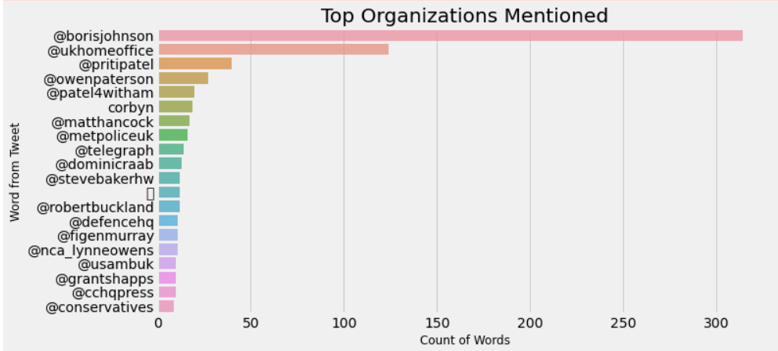

Figure 67 Top Organizations mentioned by Priti Patel

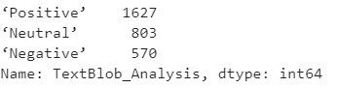

Figure 68 TextBlob Analysis of Priti Patel

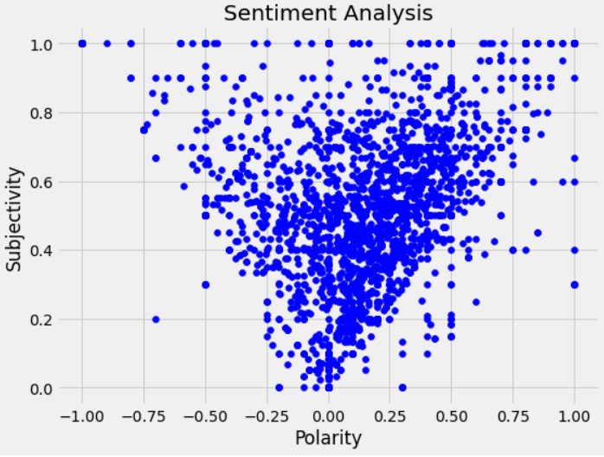

Figure 69 Sentiment Analysis of Priti Patel

#### Michael Gove

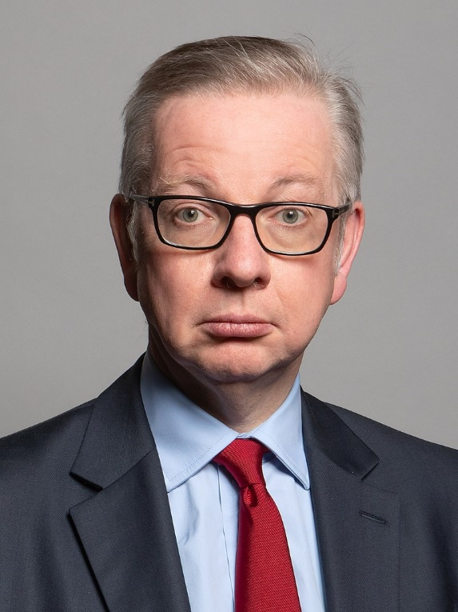

Figure 70 Portrait of Michael Gove

Michael Andrew Gove is also known as Michael Gove is the Secretary of State for Housing, Levelling up, and Communities since the 15th of September 2021. Before serving the current role Gove served as The Chancellor to the Duchy of Lancaster during the period of 2019 to 2021. Gove has been serving as a Member of Parliament for the constituency of Surrey Heath since 2005. Previous roles that Gove Cabinet Office Minister from 2020 – 2021 and Secretary for Environment, Food and Rural Affairs from 2017 – 2019 (The Rt Hon Michael Gove MP - GOV.UK, 2022).

Gove was born on 26th August 1967 in Aberdeen. Gove spent most of his early childhood getting his education from Aberdeen. Gove then studied English at Lady Margaret Hall in Oxford. Gove first joined Labour Part in 1983 as he was brought up by Labor-supporting parents, but after being in Oxford he decided to become a member of Oxford University Conservative Association and then later became the Secretary of Aberdeen South Young Conservatives and begin his journey in the conservative party. One interesting thing about Gove is he met current Prime Minister Boris Johnson at Oxford during his first year.

The Twitter analysis we performed shows us that the most common word used by Gove is great which had over 250 counts followed by words like people, today, and Boris Johnson. The interesting thing we can see is that all the conservatives have words like people, thank common among them. Based on the TextBlob analysis we performed on the tweets we can see that there are over 1740 Positive, 957 Neutral, and 303 Negative tweets, which is 58% Positive, 32% Neutral, and 10% Negative tweet rating. Gove's tweets had a polarity of 0.20641 and subjectivity of 0.421646 in his tweets. We can see the polarity plotted against subjectivity in the figure below.

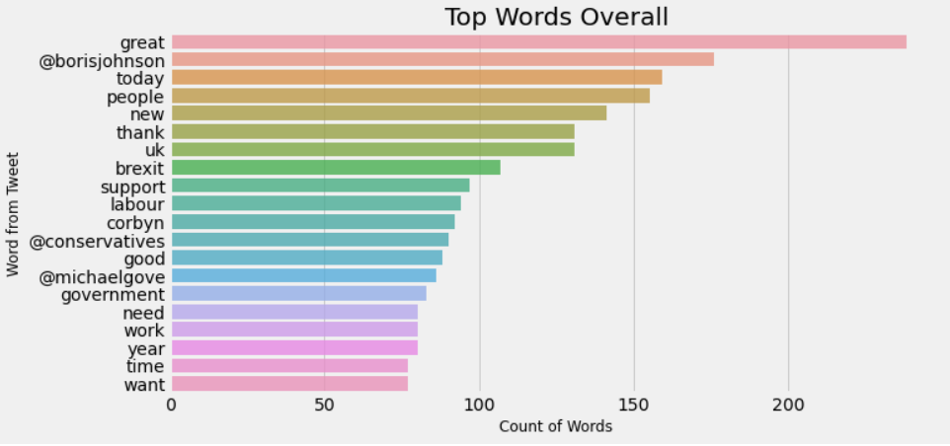

Figure 71 Top Words used by Gove

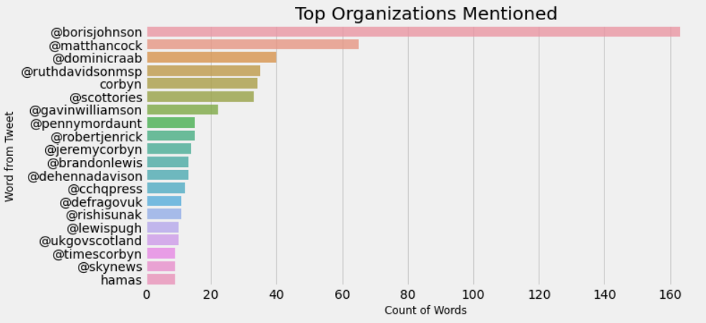

Figure 72 Top Organizations used by Gove

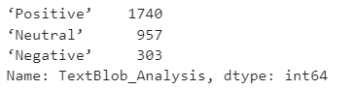

Figure 73 TextBlob Analysis on Gove

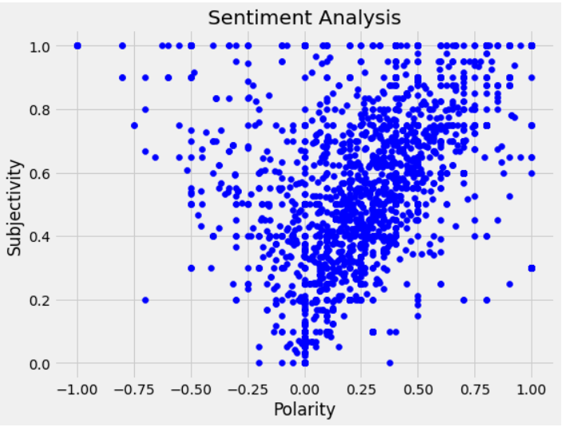

Figure 74 Sentiment Analysis on Gove

### 5.1.2 The Labour Party

The Labour Party or simply called the Labour’s are generally termed to swing towards the whole left spectrum based on their policies and their history. The Labour party we know of today has been initially known as the New Labour is dominated by the ideology of Socially Liberal Central Left, this is since Tony Blair from 2010. The leadership of the party was handled by Ed Miliband from 2010 – 2015, where the ideology of the party remained center-left, he was later replaced by Jeremy Corbyn in 2015. Corbyn was a complete left-wing politician and under his leadership, the Labour party suffered three successive election defeats and the party needed to be a much better opposition and then is right now, so they replaced Corbyn with Sir Keir Starmer, being a human rights lawyer he has risen through the ranks in the opinion polls (About Britain, 2021).

The Labour party is mostly a group of Local Labour Parties, Trade Unions, and other related associations. They get most of their funding from the Trade Unions but they don’t have influence over the party decisions and their influence over the party has been reducing ever since 2015. Labour party used to elect their leaders based on a system of electoral colleges, members, Member of Parliaments and trade unions, this was later changed in 2014 by Ed Miliband. He introduced a way in which all the paid part member and the once registered in the Labour party can pick their candidate, this backfired as it lead to the election of Corbyn as the party leader. During his time the party was polarized and had failed to take advantage of the rift and unpopularity of conservatives during their BREXIT crisis (About Britain, 2021). Let's take look at the 5 popular labor politicians based on their popularity by YouGov (The most popular Labour politicians in the UK | Politics | YouGov Ratings, 2022).

#### Keir Starmer

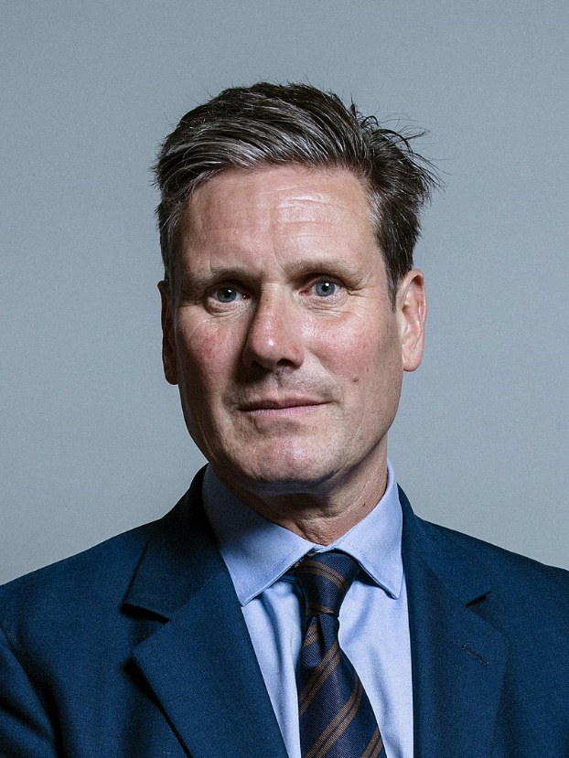

Figure 75 Portrait of Keir Starmer

Sir Keir Rodney Starmer better known as Keir Starmer is the Leader of the Labour Party and also the Opposition leader since 2020 he replaced Jeremy Corbyn. Starmer is a Member of Parliament for the constituency of Holborn and St Pancreas since 2015. Starmer was born in London on the 2nd September of 1962 and grew up in a small town in Surry called Oxted. He grew up in a Labor-supporting family and was named after the first leader of the party “Keir Hardie”.

Starmer got most of his primary education in Reigate Grammar School, where he got his 11 plus education done, and later got his Bachelors in Law from the University of Leeds in 1985 and completed his Master’s at Oxford in St Edmund Hall. Starmer was active in Labour politics since he was a teenager he was part of Surrey Young Socialists. Starmer also edited a magazine called “Socialist Alternatives” from the year 1986 to 1987. He then served as a Human rights lawyer, before moving into politics.

Observing his tweets we can see that he mentions the word Labour than any other word given as he is the leader of the labor party, he also mentions the word the government a lot as he is the opposition leader his job involves commenting and criticizing the government a lot, they're also words like “people”, “need” and “UK labor” are used a lot as well. Starmer tweets have a Positive tweet rating of 51%(with 1520 Positive Tweets), a Negative tweet rating of 19%(578 Negative Tweets), and a Neutral tweet rating of 30%(902 Neutral Tweets). Based on the political analysis we performed Starmer has a Polarity of 0.11747 and Subjectivity of 0.387289, We can see the Polarity and Subjectivity plotted against each other in the figure below.

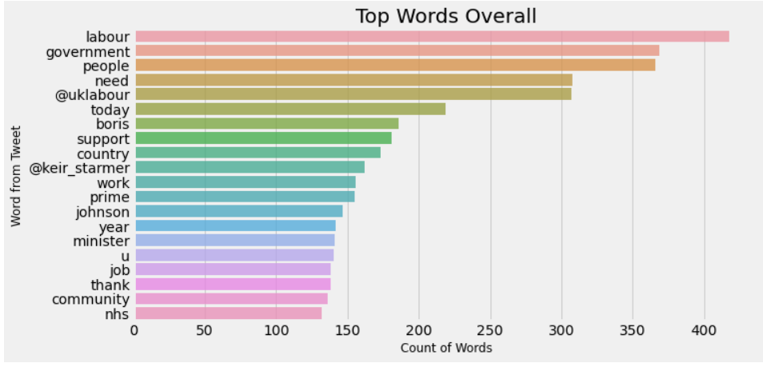

Figure 76 Top Words used by Starmer

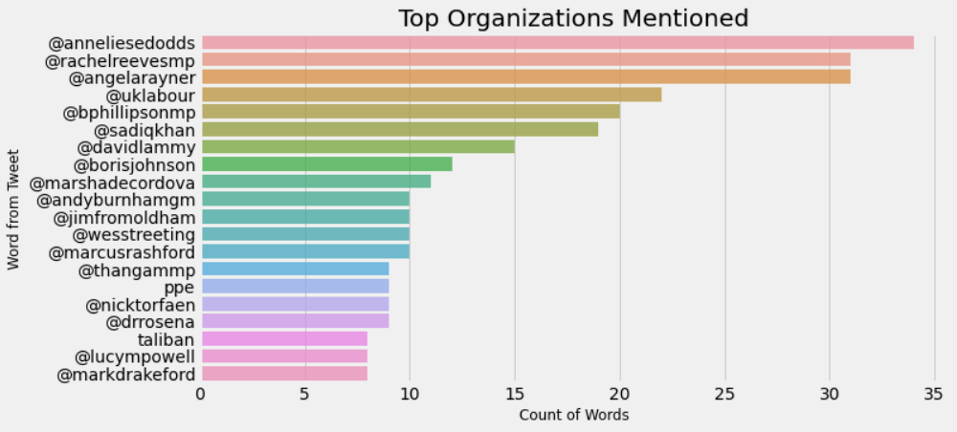

Figure 77 Top Organizations mentioned by Starmer

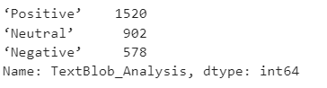

Figure 78 TextBlob Analysis of Starmer

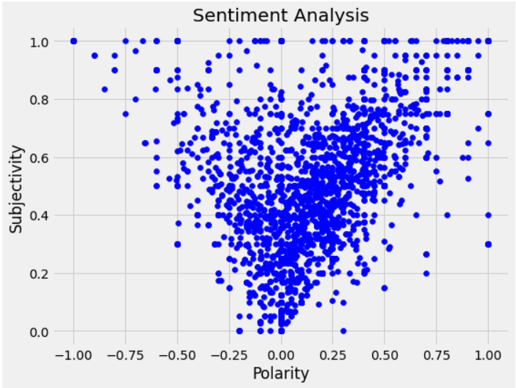

Figure 79 Sentiment Analysis of Starmer

#### Andy Burnham

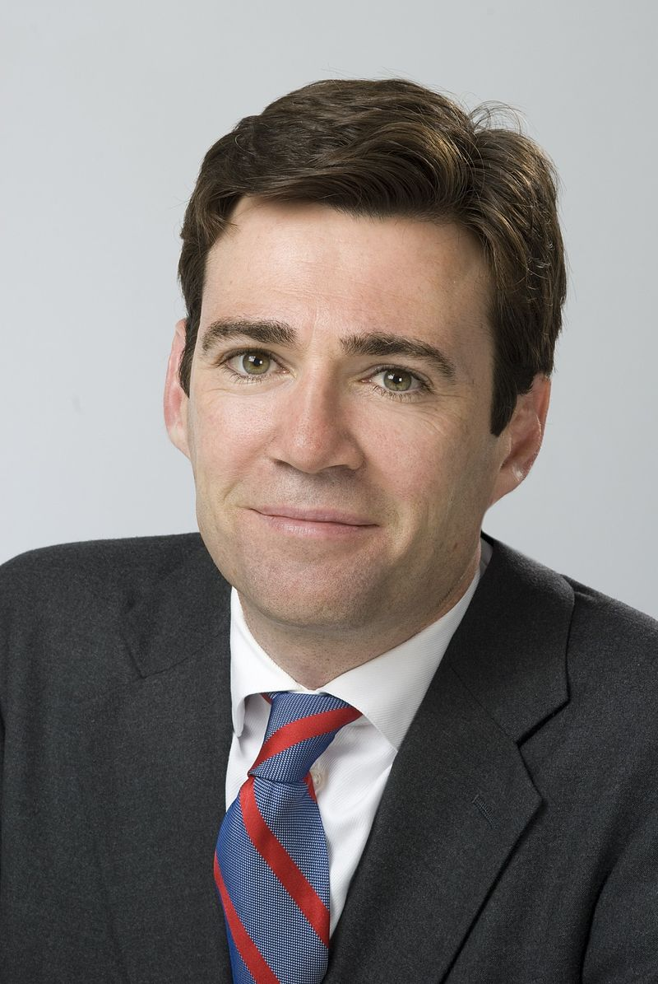

Figure 80 Portrait of Andy Burnham

Andrew Murray Burnham or also known as Andy Burnham is the Mayor of Greater Manchester and has been since 2017. He has served several other roles like being a Chief Secretary of Treasury on Gordan Brown’s cabinet from the year 2007 to 2008, Secretary of Culture, Health Secretary and also being a Shadow Home Secretary from the year 2015 – 2016. Andy was also a Member of Parliament for the constituency of Leigh for 17 years.

Andy was born in Aintree which is now part of Merseyside on 7th January 1970. He got most of his primary education from St Lewis Catholic School and then went on to Cambridge where he studied English at Fitzwilliam College. Burnham was part of the Labour party since he was a teenager at 15. He worked as a researcher for Tessa Jowell between 1994 – 1997. Burnham played an important role when he was part of the Brown Government.

Observing his tweets we can see that he mentions the emoji ‘Thumbs Up’ than any other word, they're also words like “people” and “thanks” that are used a lot as well. What stands out the most is there is a high usage of the word ‘Manchester’ as this can be because Andy is the mayor of Manchester. Andy's tweets have a Positive tweet rating of 52%(with 1571 Positive Tweets), a Negative tweet rating of 12%(359 Negative Tweets), and a Neutral tweet rating of 36%(1070 Neutral Tweets). Based on the political analysis we performed Burnham has a Polarity of 0.142671 and Subjectivity of 0.340838, We can see the Polarity and Subjectivity plotted against each other in the figure below.

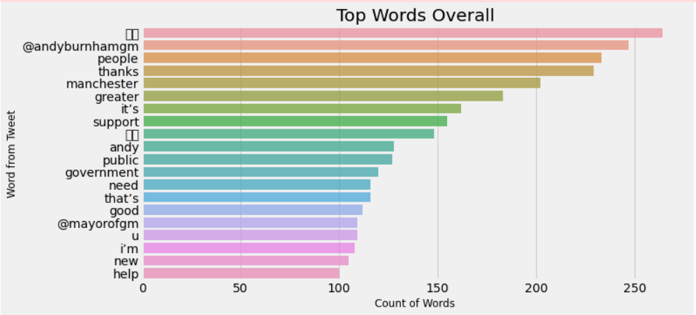

Figure 81 Most Common used words by Andy Burnham

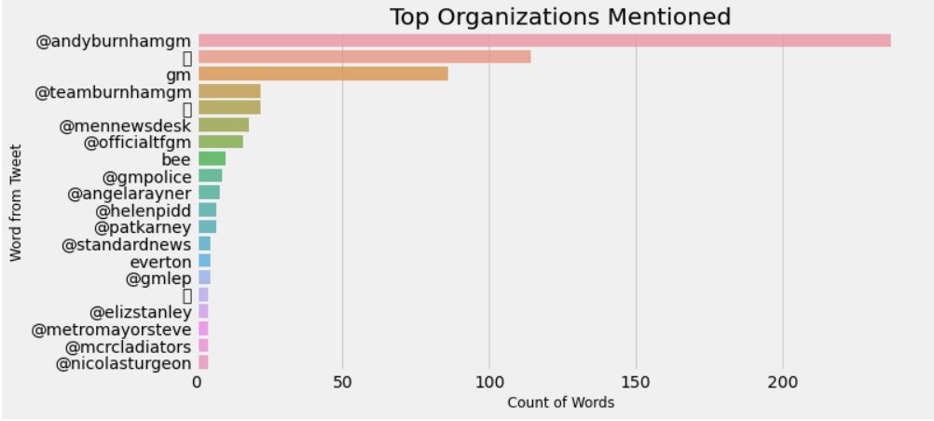

Figure 82 Most commonly mentioned organizations by Andy

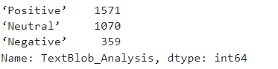

Figure 83 TextBlob Analysis of Andy

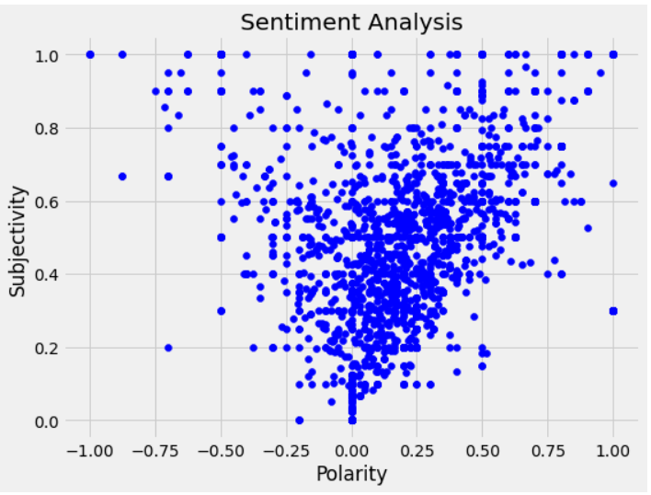

Figure 84 Sentiment Analysis of Andy Burnham

#### Sadiq Khan

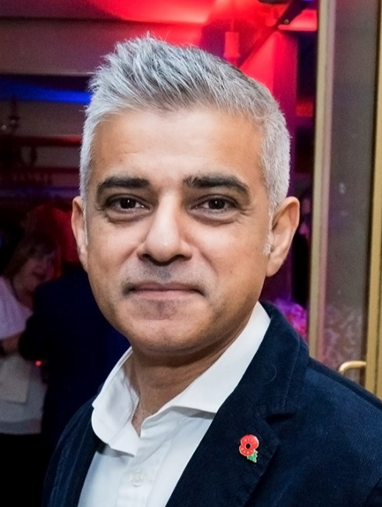

Figure 85 Portrait of Sadiq Khan

Sadiq Aman Khan or simply known as Sadiq Khan is the Mayor of London. His role gives him the authority to promote economic development throughout all the boroughs of the city of London, while also stimulating the creation of wealth, social development and also taking care of the environment. He as the mayor of London also has other important responsibilities like protecting historical monuments, increasing or stimulating tourism, protection, and development of culture. He has been the mayor of London since leading a successful labor campaign in the 2015 General Elections (Sadiq Khan | London City Hall, 2022).

Sadiq Khan was born on 8th October of 1970 to a working-class British-Pakistani family in Tooting, which is in the Southern part of London. He attended a Fircroft Primary School for his primary education, then went on to get a degree in law at then called the University of North London, which is now called London Metropolitan University. He then went on to work as a solicitor for human rights protection in Liberty advocacy group for nearly three years. After joining the Labour party Sadiq Khan worked as a councilor for Brough of Wandsworth in London from the year 1994 – 2006, and then he was elected to become a Member of Parliament for the borough of Tooting in the 2005 general elections. He then went on to become Secretary for State for Communities and Local Governments in 2008 under the leadership of Gordan Brown. From then on he also served as Transport Minister, Shadow Secretary for Justice, Lord Chancellor, and also Shadow Minister to London before becoming the Mayor of London.

Looking at the tweeter data by Sadiq Khan we can see that the word London used more than any other word, then he mentions words like new, the mayor, and also the word Londoners being mentioned often, all these words can be explained as Sadiq Khan is the Mayor of London and involves mentioning London a lot. Khan tweets have a Positive tweet rating of 59%(with 1782 Positive Tweets), a Negative tweet rating of 11%(319 Negative Tweets), and a Neutral tweet rating of 30%(899 Neutral Tweets). Based on the political analysis we performed Khan has a Polarity of 0 0.1725 and Subjectivity of 0.3918, We can see the Polarity and Subjectivity plotted against each other in the figure below.

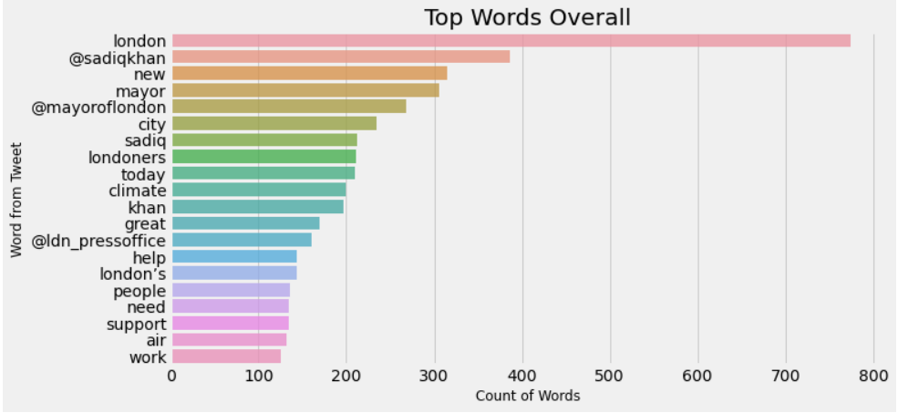

Figure 86 Top Words mentioned by Sadiq Khan

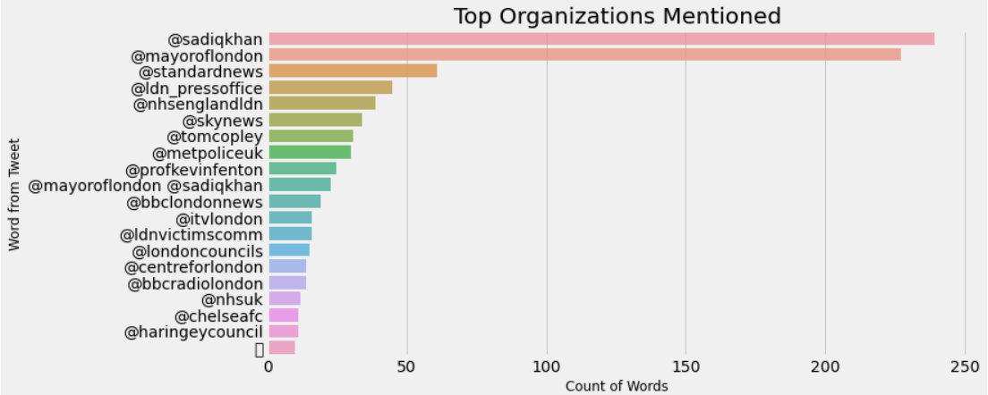

Figure 87 Top Organizations mentioned by Sadiq Khan

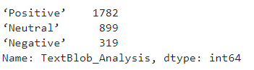

Figure 88 TextBlob Analysis of Sadiq Khan

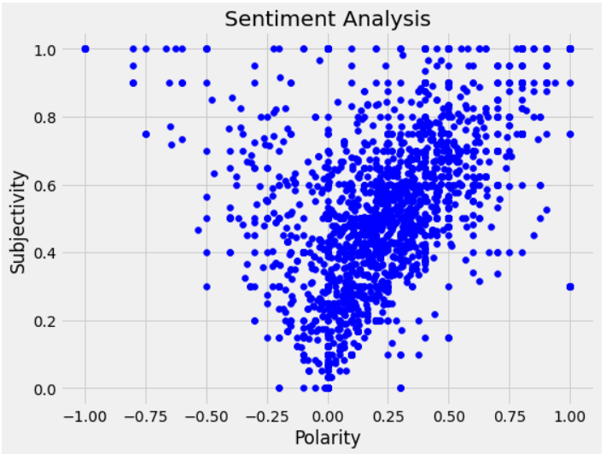

Figure 89 Sentiment Analysis of Sadiq Khan

#### Ed Miliband

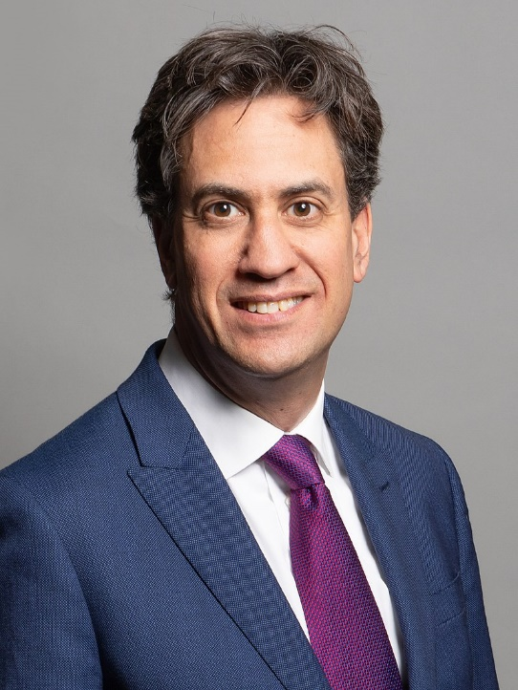

Figure 90 Portrait of Ed Miliband

Edward Samuel Miliband or simply known as Ed Miliband is currently a Shadow Secretary for Climate Change and Net Zero, he is also a Member of Parliament for the borough of Doncaster North since 2005. He is the brother of prominent Labour party leader David Miliband. He also served as a leader of opposition and leader of the Labour Party from 2010 to 2015 and resigned after the 2015 general election defeat.

Ed Miliband was born on 24th December of 1969 to Polish-Jewish immigrant parents, in the Fitzrovia district of Central London. His father was a Marxist intellectual who was native to Brussels and then fled during World War II. Ed got his degree in Philosophy, Politics, and Economics from Oxford at Corpus Christi College. After finishing his degree at Oxford Ed worked as a media researcher to Andrew Rawnsley for Channel 4 to a popular show called ‘A Week in Politics’. Ed also had a short stint at Harward where he was a ‘Visiting Scholar’ where he taught economics for three semesters and also taught a course titled "What's Left? The Politics of Social Justice". He then came back to the UK and joined his brother in the cabinet of Gordon Brown.

When we look at Ed’s Twitter data we can see that he mentions the word ‘cheerfulpodcast’ more than any other word, if we do a quick google search we can see that he is one of the hosts of a podcast called ‘Cheerful’ which explores the ideas, people and movement to solve biggest challenges facing the society. He also mentions the word ‘government’ and ‘need’ which seem to be a common trend among Labour party members as their job is to criticize the government. We can also see the words like climate and green used a lot this gives us insight into his current position as a Secretary for Climate Change and Net-Zero. Ed’s tweets have a Positive tweet rating of 53%(with 1591 Positive Tweets), a Negative tweet rating of 19%(559 Negative Tweets), and a Neutral tweet rating of 28%(850 Neutral Tweets). Based on the political analysis we performed Miliband has a Polarity of 0.1216506 and Subjectivity of 0.39023731, We can see the Polarity and Subjectivity plotted against each other in the figure below.

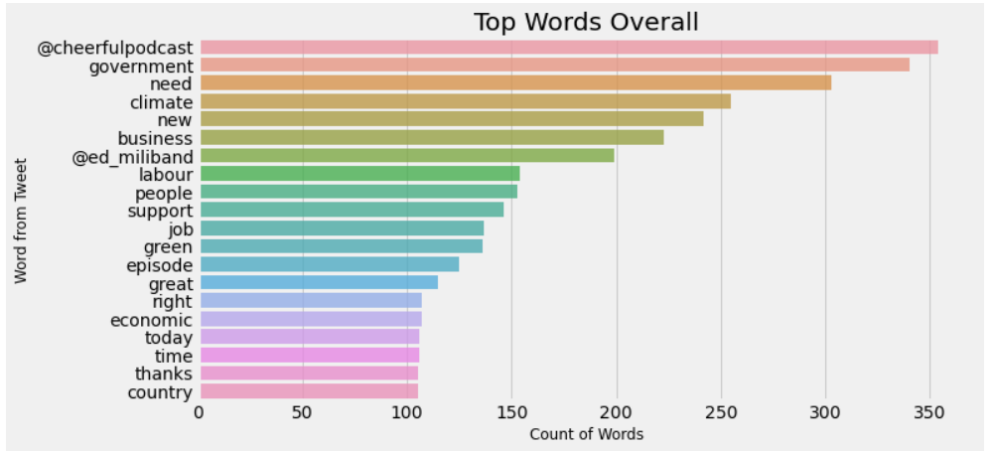

Figure 91 Top Words mentioned by Ed Miliband

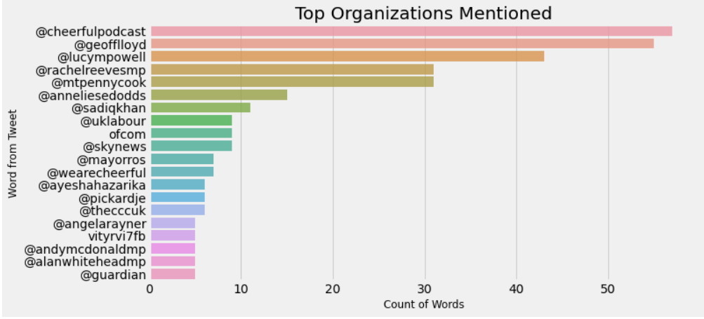

Figure 92 Top organizations mentioned by Ed Miliband

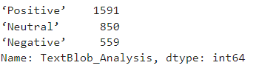

Figure 93 TextBlob analysis for Ed Miliband

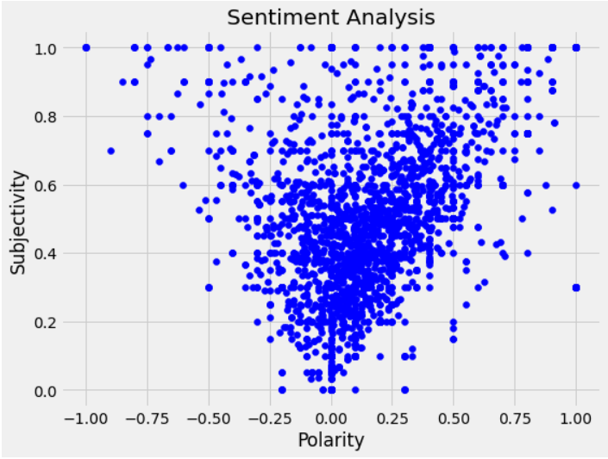

Figure 94 Sentiment Analysis for Ed Miliband

#### Jeremy Corbyn

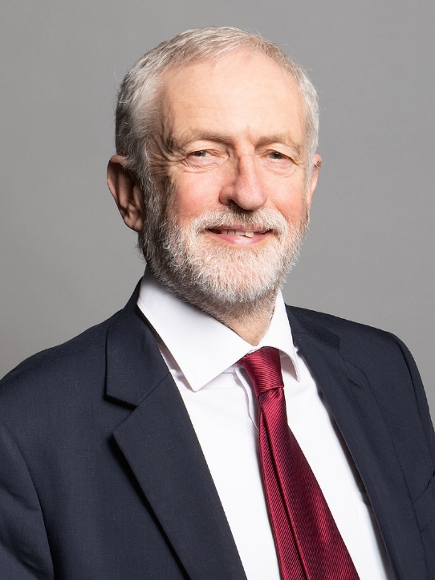

Figure 95 Portrait of Jeremy Corbyn

Jeremy Bernard Corbyn or known as Jeremy Corbyn was the leader of the opposition party and opposition from the year of 2015 to 2020. Corbyn identifies himself as a socialist. Corbyn is currently serving as a Member of Parliament for the borough of Islington North where he has been holding his seat since 1983. He was elected the leader of the Labour Party in 2015 and then had to resign after the defeat in the General Elections. Corbyn had a long history with the Labour party, he was with the Labour party since the year 1979 where he was an organizer for general elections in Hornsey.

Corbyn was born on 26th May 1949 in Wiltshire county. He comes from a family who supported the Labour family and had that influence while growing up. Corbyn got most of his primary education from Adam Grammar School and then joined Wrekin constituency Young Socialists, his local Labour Party. As a teenager, he participated in many protests like Against Cruel Sports, Campaign for Nuclear Disarmament and also campaigned against Vietnam War. Corbyn also worked as a reporter for a local newspaper called ‘*Newport and Market Drayton Advertiser*. Throughout his time with the Labour party, Corbyn worked in different roles. During the time Labour was in power he was a prominent backbencher who was always against party whips.

While analyzing the tweets by Corbyn we can see that he follows the same trend as the other Labour party leaders using the words ‘people’, ‘government’, ‘NHS’ and ‘need’. This tells us that the Labour party is the opposition constantly puts more pressure on the government as that’s one of its duties. When we look at Corbyn’s TextBlob analysis we can see his tweets have a Positive tweet rating of 50%(with 1499 Positive Tweets), a Negative tweet rating of 17%(506 Negative Tweets), and a Neutral tweet rating of 33%(995 Neutral Tweets). Based on the political analysis we performed Miliband has a Polarity of 0.121295 and Subjectivity of 0.37196331, We can see the Polarity and Subjectivity plotted against each other in the figure below.

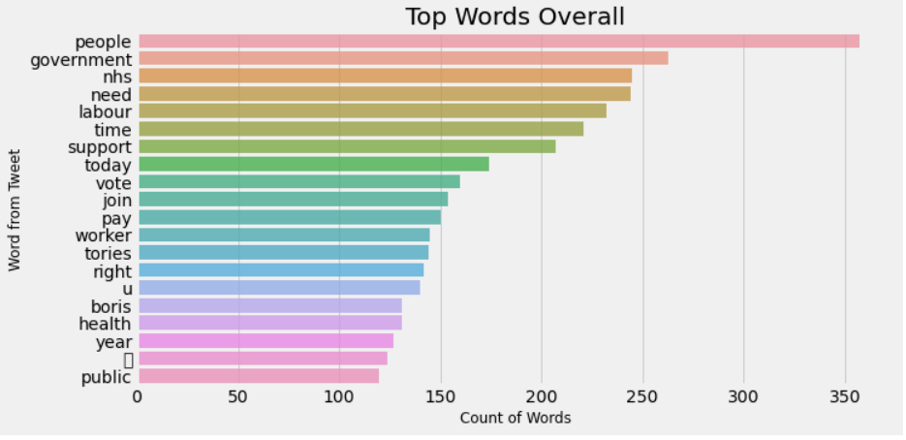

Figure 96 Top Words mentioned by Corbyn

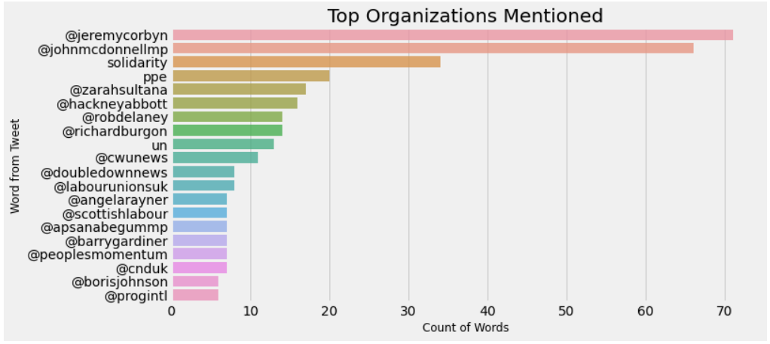

Figure 97 Top Organizations mentioned by Corbyn

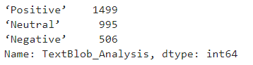

Figure 98 TextBlob Analysis of Corbyn

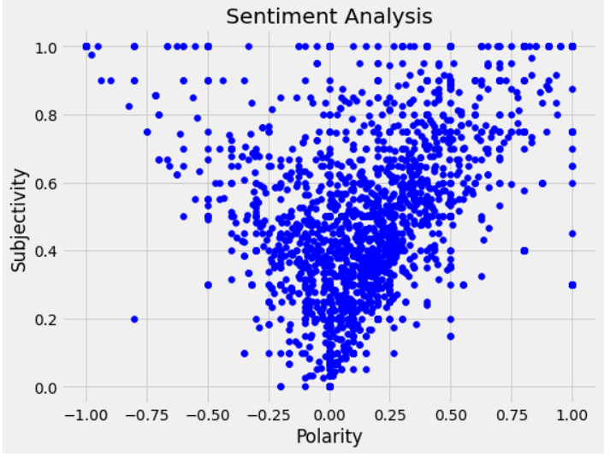

Figure 99 Sentiment Analysis of Corbyn

## 5.2 United States of America

The politics in the United States of America boil down to two political parties Democratic Party and Republic party. Democratic party support groups are usually boiled down to The Poor – the section of people who depend on public funds and government aid like Medicaid or Obama Care, as democratic policies tend more to social welfare and more sympathetic towards them, Minorities – these demographics include the people of different races like African Americans, Asians and Hispanics where democratic policies involve frier immigration policies, and Liberals – Section of people who support higher government intervention and control over the economy, better LGBTQ rights, support for Abortion and stricter gun control. On the Republican side, you have Wealthy people – A section of people who are economically richer and want limited government integration on the economy, White People, and Conservatives – the demographic of people who aren’t in favor of abortion, and usually aren’t LGBTQ friendly and are against gun control (BBC, 2022).

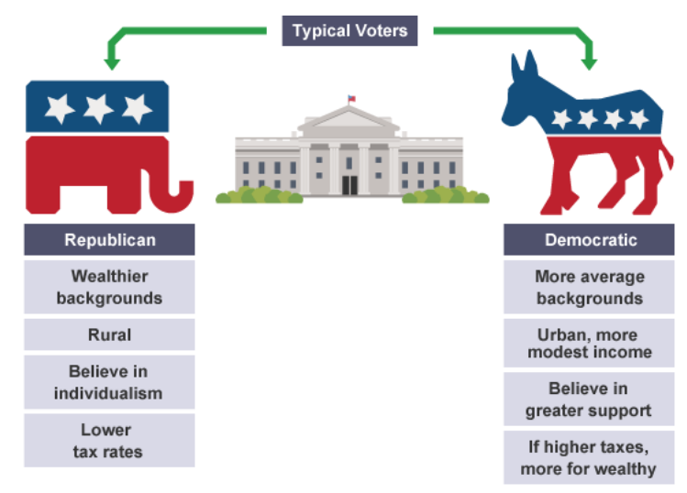

Figure 100 Typical demographic distribution on political parties

### 6.1 Democrats

#### Joe Biden

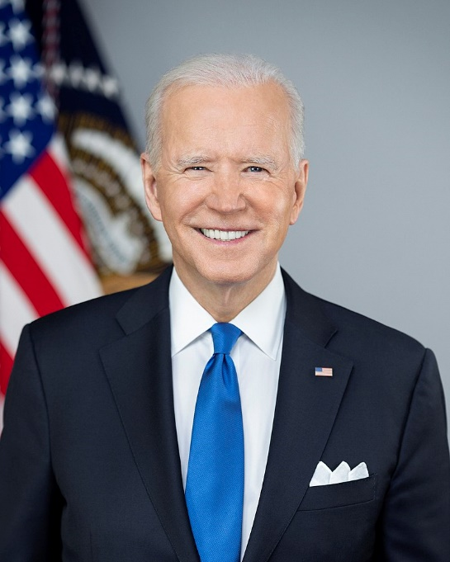

Figure 101 Portrait of Joe Biden

Joseph Robinette Biden Jr or simply known as Joe Bidden is the current and 46th president of the United States of America, before serving as the president he also served as the vice president of the Obama administration. Biden was born in Scranton located in the state of Pennsylvania. He has served as senator for Delaware for 36 years, and Bidden was one of the youngest to ever be elected into congress. Biden is pretty popular for spearheading a successful campaign to bring higher better laws against abuse and violence towards women, this resulted in an act known as ‘Violence against Woman Act’ (Joe Biden: The President | The White House, 2022).

Biden was born and raised in Pennsylvania, and then moved to Delaware after the age of 10. He got his degree in law from Syracuse University in 1968 and is part of the Delaware bar since 1969. Bidden had to go through a lot of personal trauma in his life, this included the death of his wife and son by an automobile accident weeks after his re-election in 1972. Bidden has been part of the senate from 1973 to 2009, and served as vice president for two terms for President Obama.

While looking at Biden’s tweets one interesting thing that we can see is that even after Trump’s defeat in the general elections we can still see that Biden mention ‘Trump’ and ‘Donald’ more than any other word. Words like ‘president’, ‘American’, and ‘Build’ have a high number of mentions as well. When we perform TextBlob analysis on Biden’s tweets we can see his tweets have a Positive tweet rating of 52%(with 1566 Positive Tweets), Negative tweet rating of 15%(449 Negative Tweets), and Neutral tweet rating of 33%(985 Neutral Tweets). Based on the political analysis we performed Biden has a Polarity of 0.110736 and Subjectivity of 0.321477, We can see the Polarity and Subjectivity plotted against each other in the figure below.

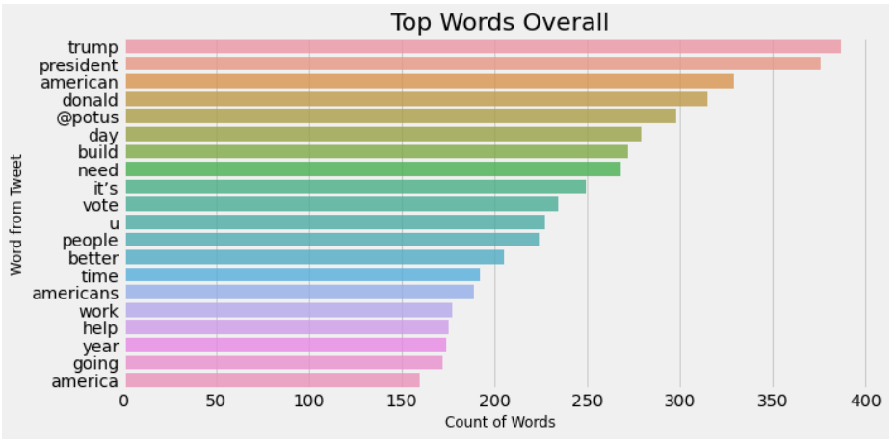

Figure 102 Top Words mentioned by Joe Biden

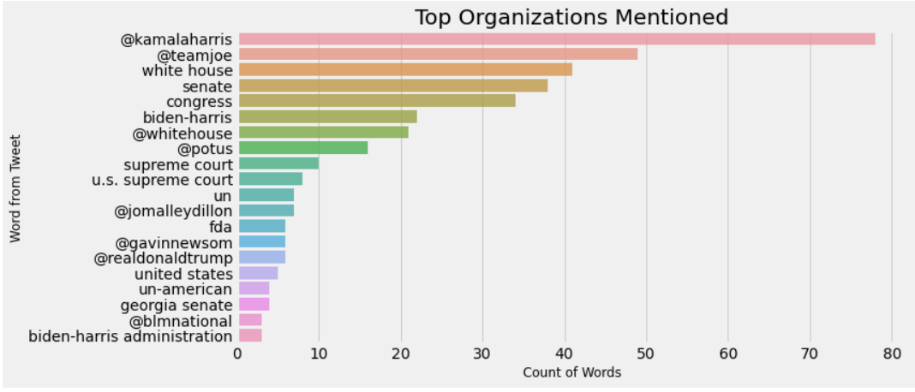

Figure 103 Top Organizations mentioned by Joe Biden

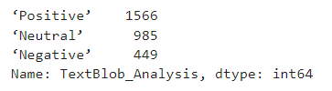

Figure 104 TextBlob Analysis on Joe Biden

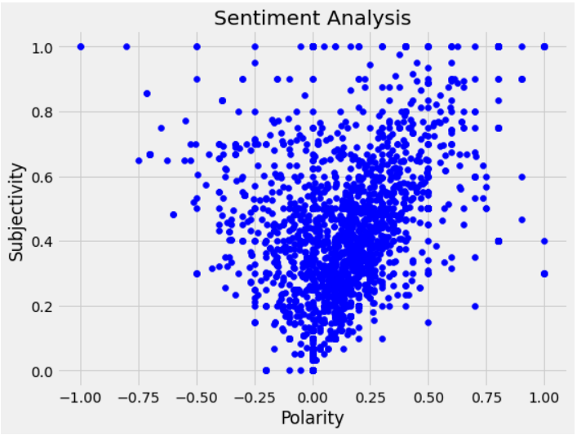

Figure 105 Sentiment Analysis on Joe Biden

#### Kamala Harris

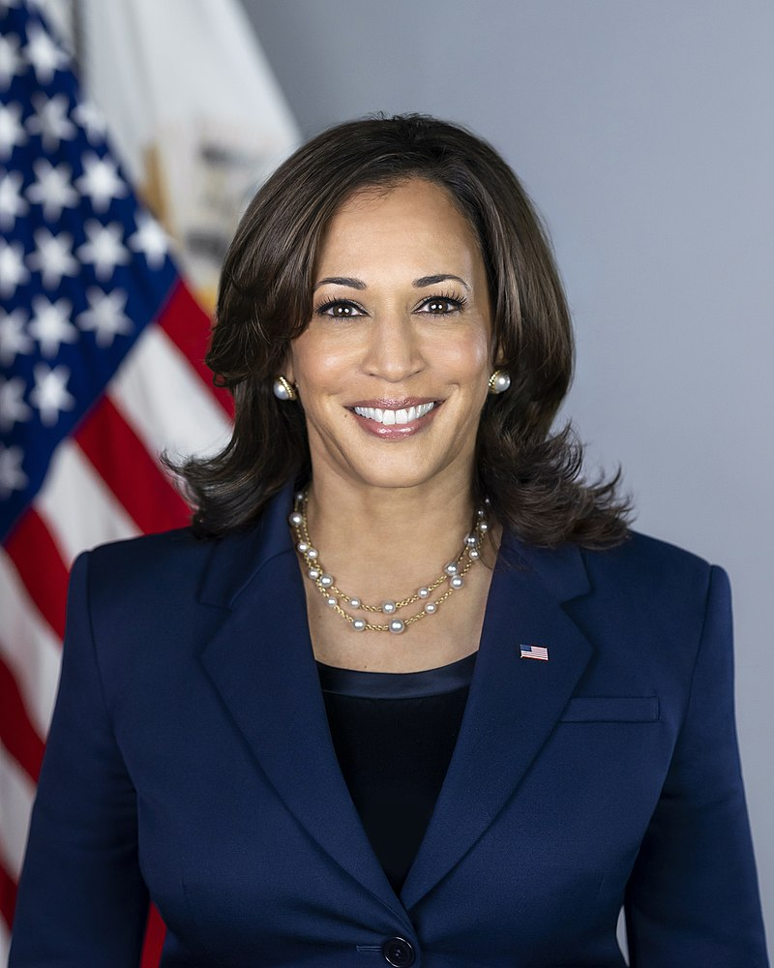

Figure 106 Portrait of Kamala Harris

Kamala Devi Harris or better known as Kamala Harris is the 49th and current vice president of the United States. Kamala Harris is also the first female Vice President and the highest-ranking female in the history of the United States. Before becoming the Vice President Kamla Harris served as a Senator of the state of California from 2017 to 2021 and also was Attorney General for California from the year 2011 to 2017.

Harris was born on 20th October 1964 in Oakland, California. She was born to immigrant parents who arrived in the United States in 1958. Harris got her degree in law from the University of California at Hastings College of Law. Harris says she was influenced by both Jamaican and Indian culture while growing up and helped her become the person she is today.

While we look at the tweets by Harris we can see that she tweets about ‘Joe Bidden’ than any other word and this can be explained as a lot of her duty involves backing up the president and supporting his policies. We can still see the word ‘Trump’ get a lot of mentions this is interesting as he lost the re-election and isn’t on the platform anymore. When we perform TextBlob analysis on Harris's tweets we can see his tweets have a Positive tweet rating of 54%(with 1628 Positive Tweets), a Negative tweet rating of 15%(452 Negative Tweets), and a Neutral tweet rating of 31%(920 Neutral Tweets). Based on the political analysis we performed Harris has a Polarity of 0.125571831 and Subjectivity of 0.355389085, We can see the Polarity and Subjectivity plotted against each other in the figure below.

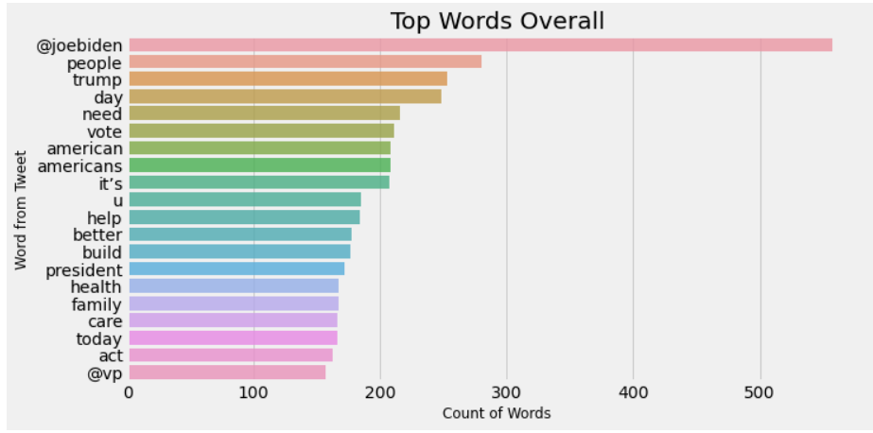

Figure 107 Top Words mentioned by Harris

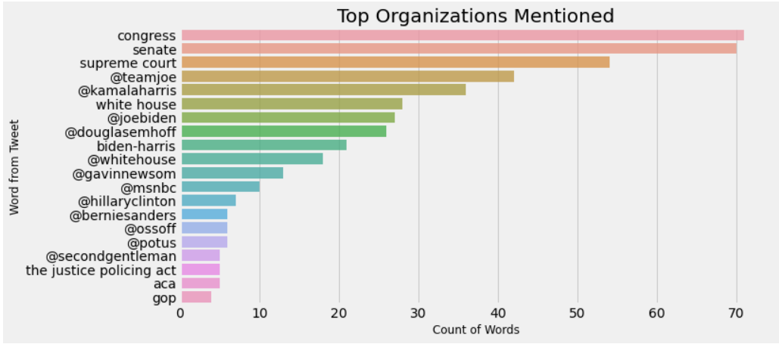

Figure 108 Top Organizations mentioned by Harris

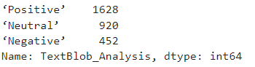

Figure 109 TextBlob Analysis of Harris

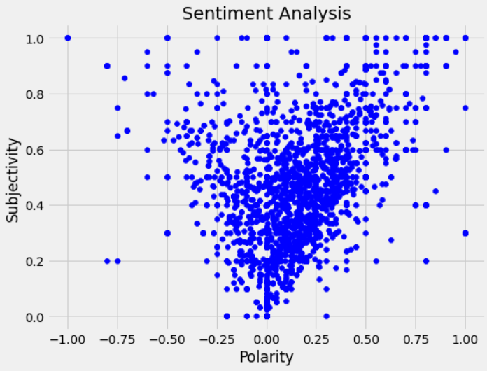

Figure 110 Sentiment Analysis of Harris

#### Alexandria Ocasio-Cortez

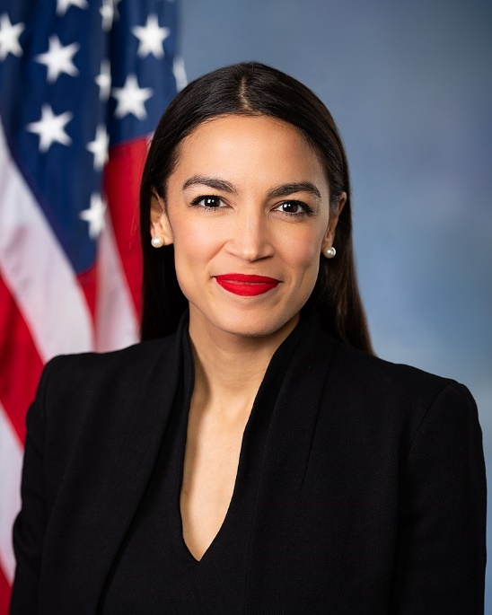

Figure 111 Portrait of AOC

Alexandria Ocasio-Cortez or well known as AOC is a popular congresswoman for New York’s 14th congressional district since 2019 and is a member of the Democratic Party. She is the youngest woman to ever be elected to the US Congress at age of 29. She has been popular for her vocal stance on many issues and her support of programs like Green New Deal, Tuition-Free Universities, Medicare for everyone, Defunding Immigration and Customs Enforcement(ICE), and many other popular socialist policies.

AOC was born on 13th October 1989 in the Bronx in the borough of New York City. She was born to an immigrant family who moved from Puerto Rico. AOC got most of her primary education from Yorktown High School and then proceeded to move on to get her education from Boston University. She started her political journey in 2016 when she was an organizer for ‘Bernie Sanders Presidential Campaign’ which led her to recognition by many prominent Democrats and helped her get into Democratic Caucus.

Looking at her tweets we can see that she tweets the word ‘it’s’ a lot, which explains why she uses the term ‘it’s time to change and ‘it’s enough, and many more such phrases. We can also see that the words ‘people’, ‘need’, ‘thank’, and ‘new’ seem to be common with a lot of democrats. When we perform TextBlob analysis on AOC tweets we can see his tweets have a Positive tweet rating of 47%(with 1409 Positive Tweets), Negative tweet rating of 19%(580 Negative Tweets), and Neutral tweet rating of 34%(1011 Neutral Tweets). Based on the political analysis we performed AOC has a Polarity of 0.0885364 and Subjectivity of 0.3524239, We can see the Polarity and Subjectivity plotted against each other in the figure below.

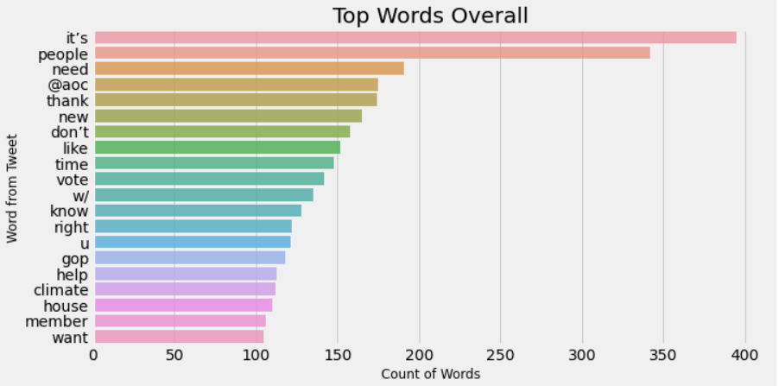

Figure 112 Top Words used for AOC

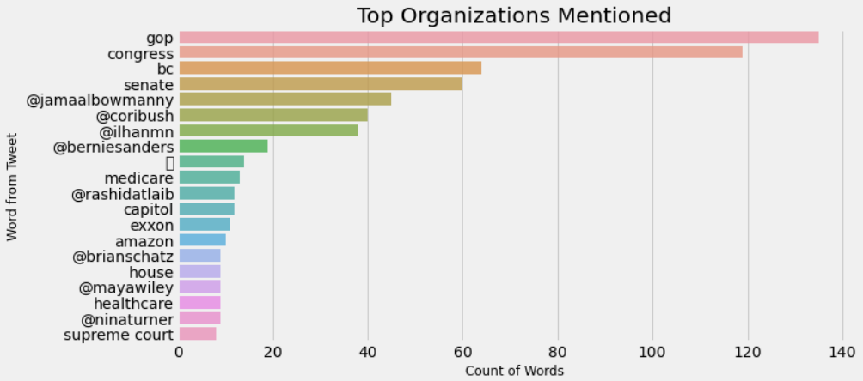

Figure 113 Top Organizations used for AOC

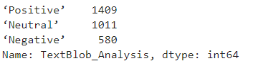

Figure 114 TextBlob Analysis on AOC

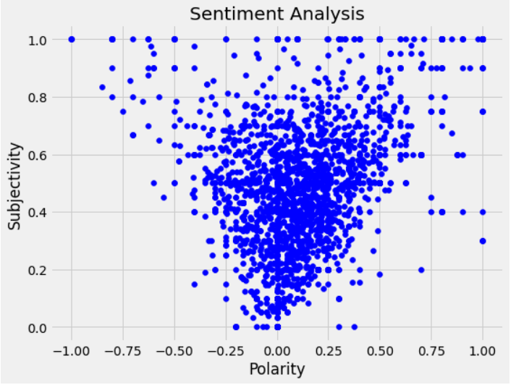

Figure 115 Sentiment Analysis on AOC

#### Bernie Sanders

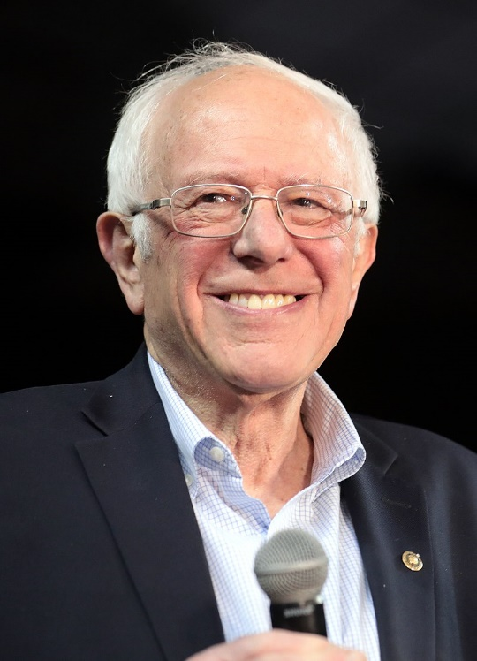

Figure 116 Portrait of Bernie Sanders

A quick analysis of US senators from Vermont shows some interesting results. We can see the word ‘people’ being used often more than any other word. He also uses words like ‘working’, ‘need’, ‘worker’ and ‘health’ a lot, which explains as these are the common words that are used to describe the need for better health care, words like working together and working class, and people seem to be a very common word among all the politicians we have seen. When we look at his TextBlob analysis we can see that Bernie tweets we can see his tweets have a Positive tweet rating of 56%(with 1680 Positive Tweets), a Negative tweet rating of 22%(654 Negative Tweets), and a Neutral tweet rating of 22%(655 Neutral Tweets). Based on the political analysis we performed Bernie has a Polarity of 0.0958238 and Subjectivity of, 0.40258808 We can see the Polarity and Subjectivity plotted against each other in the figure below.

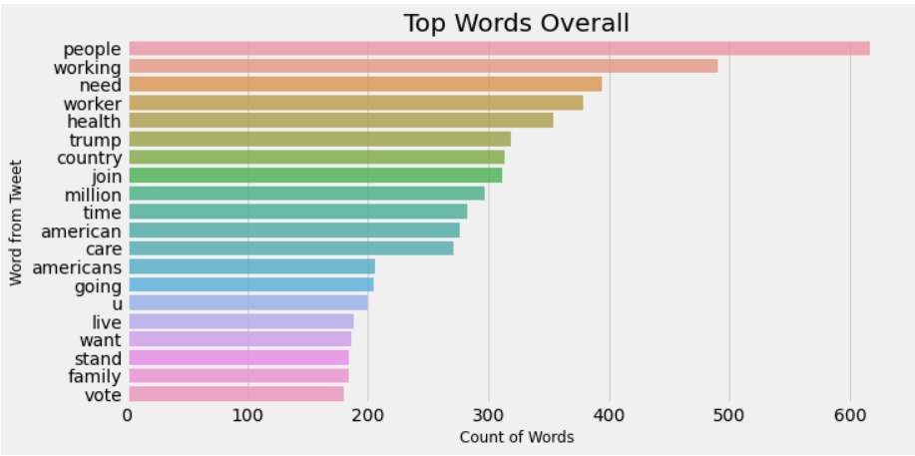

Figure 117 Top Words used by Bernie Sanders

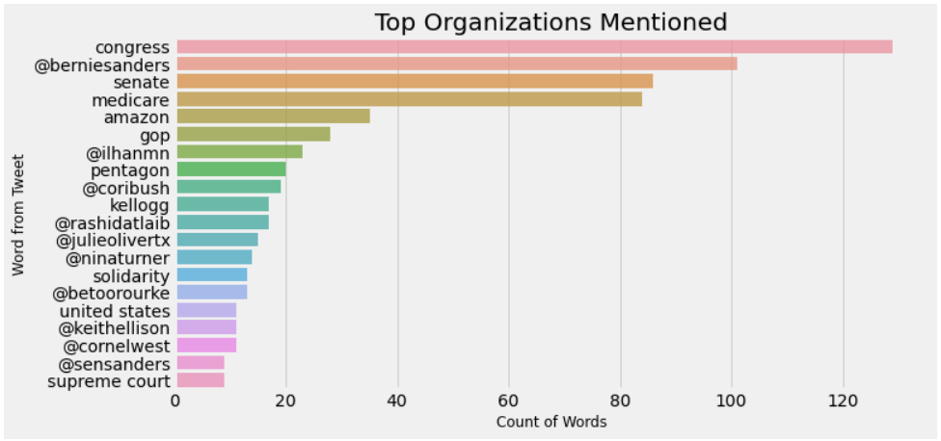

Figure 118 Top Organizations used by Bernie Sanders

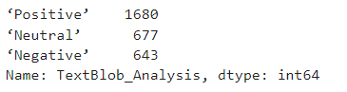

Figure 119 TextBlob Analysis on Bernie Sanders

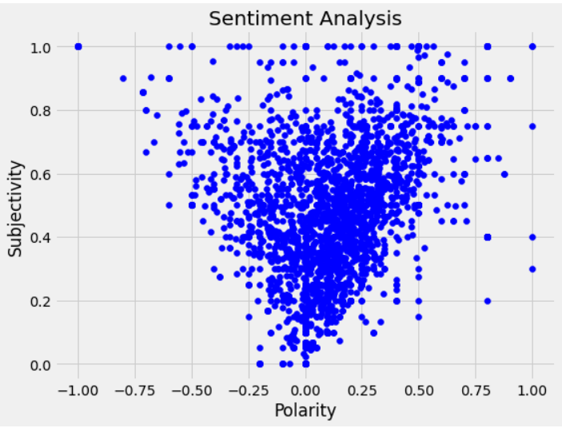

Figure 120 Sentiment Analysis of Bernie Sanders

#### Hillary Clinton

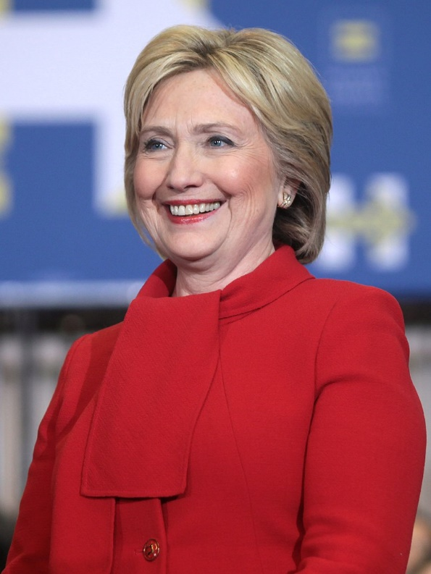

Figure 121 Portrait of Hilary Clinton

Popular democratic member Hilary Clinton who famously lost the US general election to Donald Trump. Based on her Twitter data we can see that she uses the word ‘new’ more than any other word, we can see that she also uses the words like ‘right’, ‘people’, ‘join’, and ‘vote’ a lot. When we look at her TextBlob analysis we can see that Hilary tweets we can see his tweets have a Positive tweet rating of 59%(with 1777 Positive Tweets), a Negative tweet rating of 12%(360 Negative Tweets), and a Neutral tweet rating of 29%(863 Neutral Tweets). Based on the political analysis we performed Hilary has a Polarity of 0.16283279 and Subjectivity of 0.395907. We can see the Polarity and Subjectivity plotted against each other in the figure below.

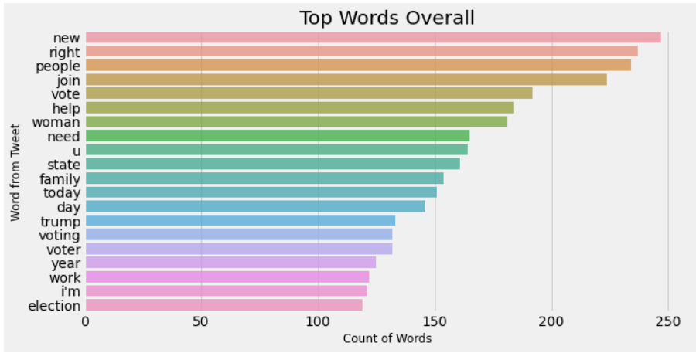

Figure 122 Top Words used by Hilary

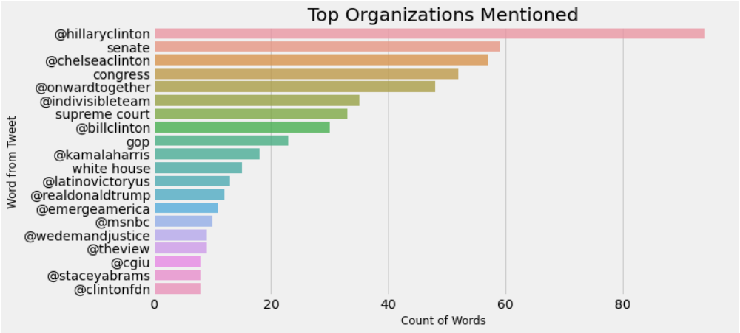

Figure 123 Top Organizations used by Hilary

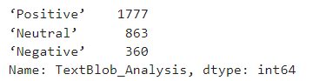

Figure 124 TextBlob Analysis for Hilary

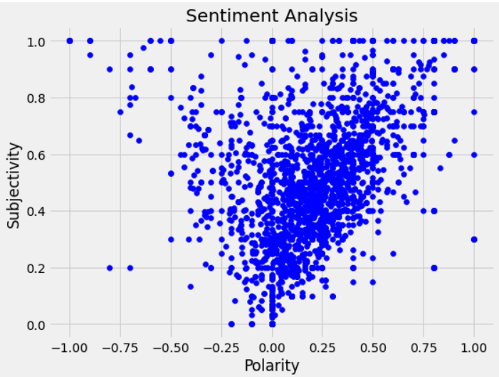

Figure 125 Sentiment Analysis of Hilary

### 6.2 Republicans

#### Ted Cruz

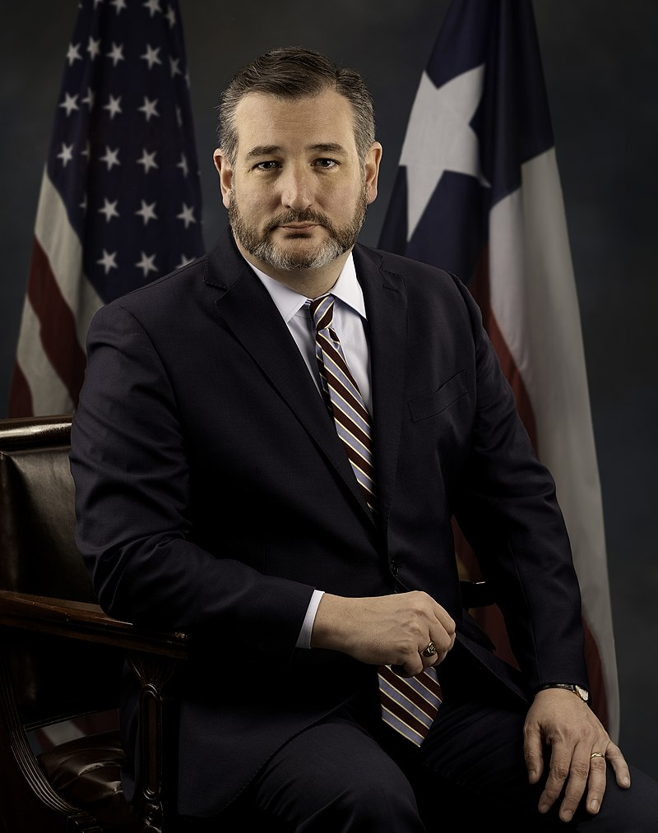

Figure 126 Portrait of Ted Cruz

Ted Cruz has been serving as a senator for the state of Texas since 2013. When we start looking at his Twitter data one interesting thing we can see is that he mentions himself the most which are incredibly interesting, we can see words like ‘Ted’, and ‘Cruz’ being mentioned a lot. Also can see him mention Biden and it is explained as he constantly criticizes the president being in opposition. When we look at his TextBlob analysis we can see that Cruz tweets we can see his tweets have a Positive tweet rating of 34%(with 1022 Positive Tweets), a Negative tweet rating of 21%(633 Negative Tweets), and a Neutral tweet rating of 45%(1345 Neutral Tweets). Based on the political analysis we performed Ted has a Polarity of 0.0419785 and Subjectivity of 0.3255966. We can see the Polarity and Subjectivity plotted against each other in the figure below.

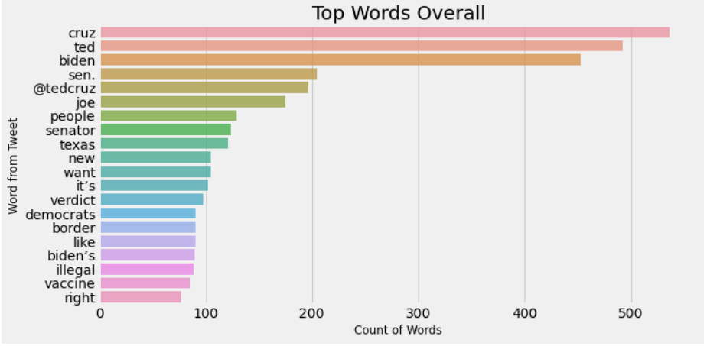

Figure 127 Top Words used by Ted Cruz

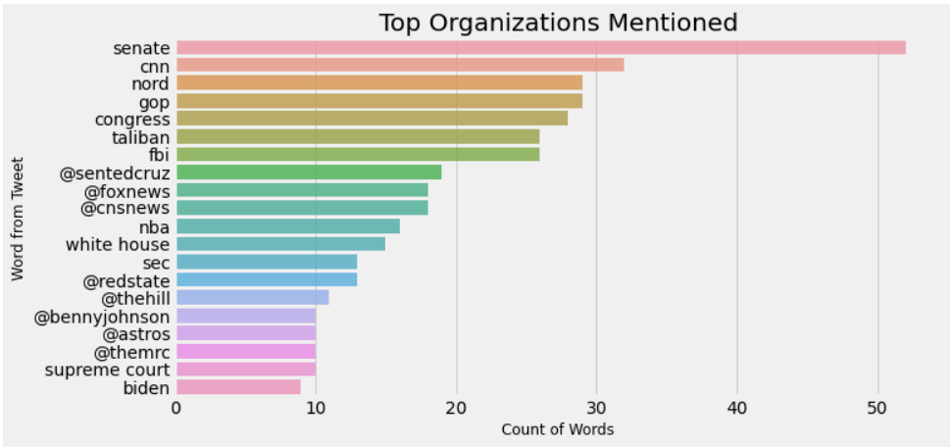

Figure 128 Top Organizations used for Ted Cruz

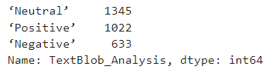

Figure 129 TextBlob Analysis for Ted Cruz

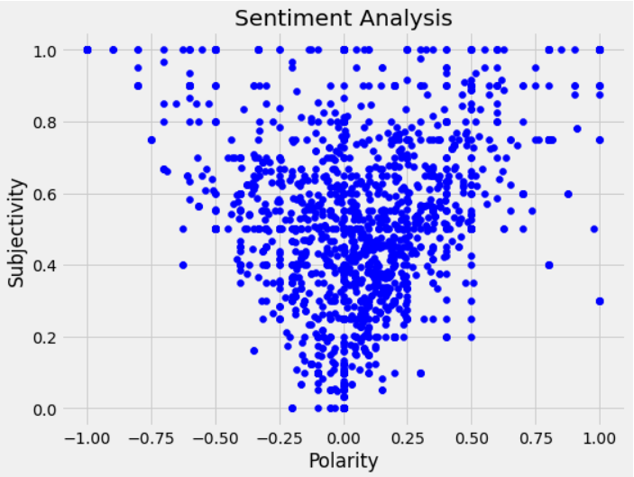

Figure 130 Sentiment Analysis of Ted Cruz

#### Lindsey Graham

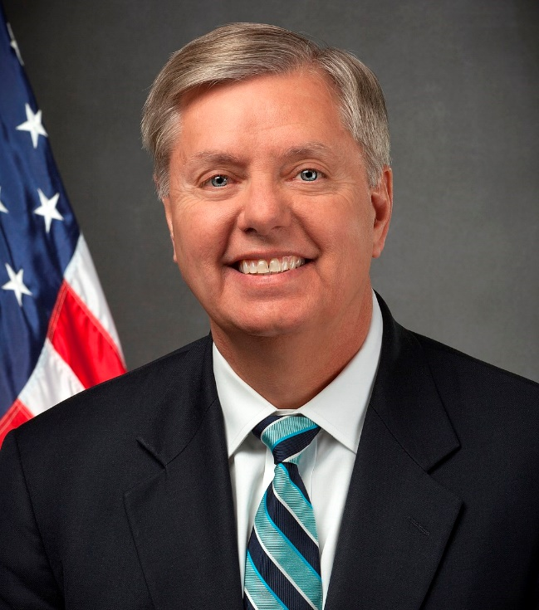

Figure 131 Portrait of Lindsey Graham

Lindsey Graham is a senator from South Carolina. When we look at the Twitter data we can see that he uses the word ‘president’ more than any other word and he also mentions words like ‘Biden’, ‘senate’, and ‘trump’ a lot. These can be explained as he with other republicans' main job is to criticize the current government. When we look at his TextBlob analysis we can see that Lindsey tweets we can see his tweets have a Positive tweet rating of 50%(with 1507 Positive Tweets), a Negative tweet rating of 19%(563 Negative Tweets), and a Neutral tweet rating of 31%(930 Neutral Tweets). Based on the political analysis we performed Lindsey has a Polarity of 0.10358881 and Subjectivity of 0.3794193. We can see the Polarity and Subjectivity plotted against each other in the figure below.

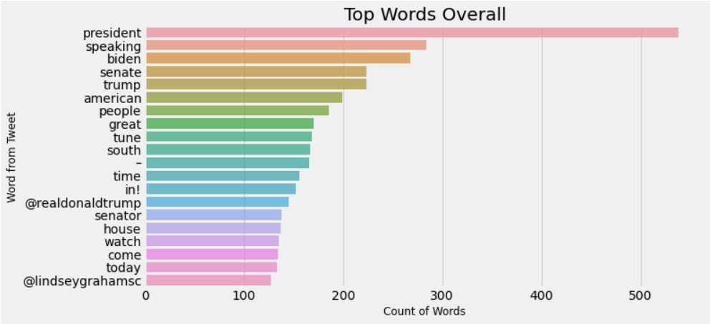

Figure 132 Top Words used by Lindsey

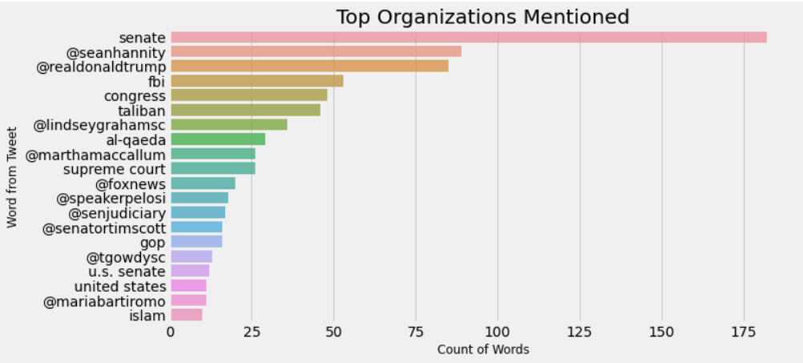

Figure 133 Top organizations used by Lindsey

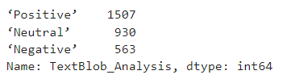

Figure 134 TextBlob Analysis of Lindsey

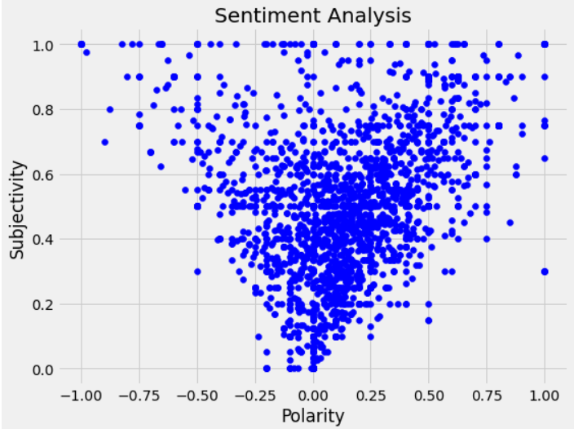

Figure 135 Sentiment Analysis of Lindsey

#### Mike Pence

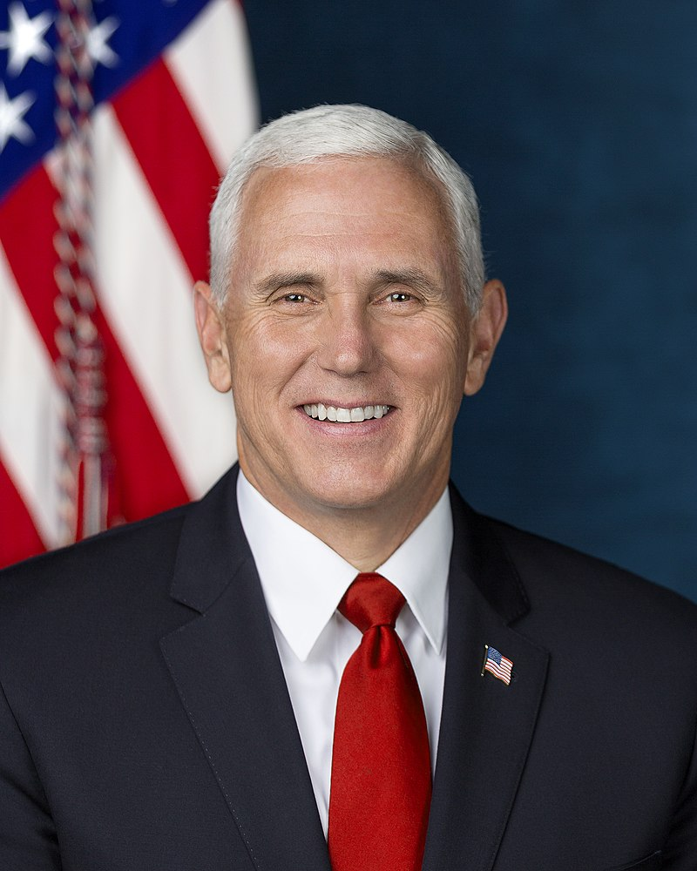

Figure 136 Portrait of Mike Pence

Mike Pence was the 48th Vice President of the United States and he also served as the governor for the state of Indiana. When we look at the tweets we can see that he uses the word ‘president’ more than any other word and it seems to be a common thing among all the Republicans. We can also see him using the words ‘American’, ‘Great’, and ‘America’ get mentioned a lot. The interesting thing we can also see is that he mentions ‘Trump’ a lot and seems to be a common thing and interesting part is Trump hasn’t been on Twitter for more than a year after being banned for promoting false information. When we look at his TextBlob analysis we can see that Mike tweets we can see his tweets have a Positive tweet rating of 49%(with 1458 Positive Tweets), a Negative tweet rating of 6%(195 Negative Tweets), and a Neutral tweet rating of 34%(1020 Neutral Tweets). Based on the political analysis we performed Mike has a Polarity of 0.200225 and Subjectivity of 0.335375852. We can see the Polarity and Subjectivity plotted against each other in the figure below.

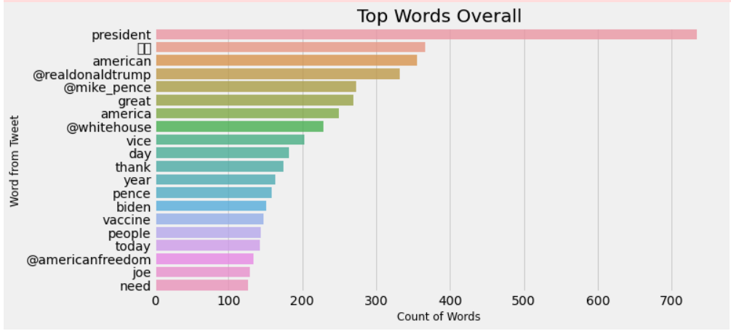

Figure 137 Top Words mentioned by Mike Pence

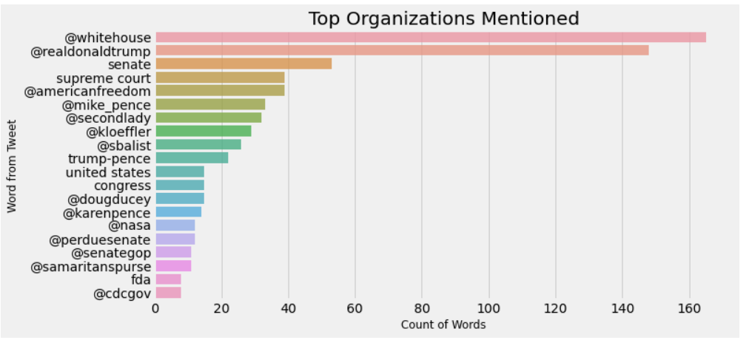

Figure 138 Top Organizations mentioned by Mike Pence

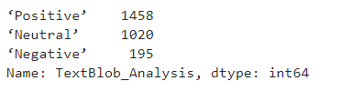

Figure 139 TextBlob Analysis of Mike Pence

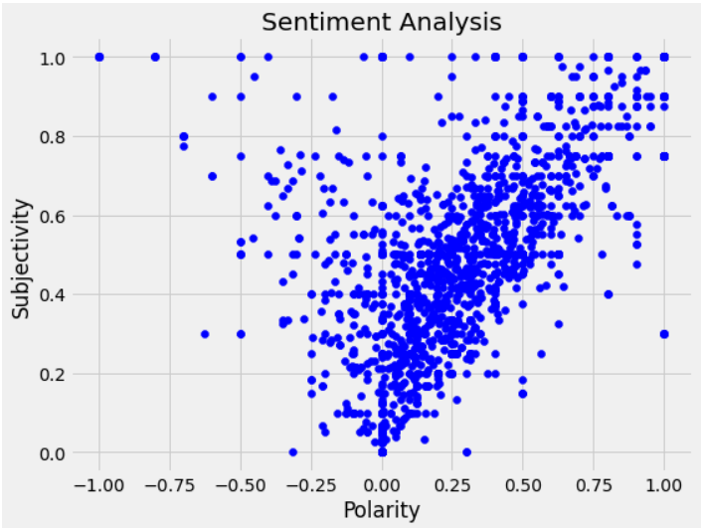

Figure 140 Sentiment Analysis of Mike Pence

#### Marco Rubio

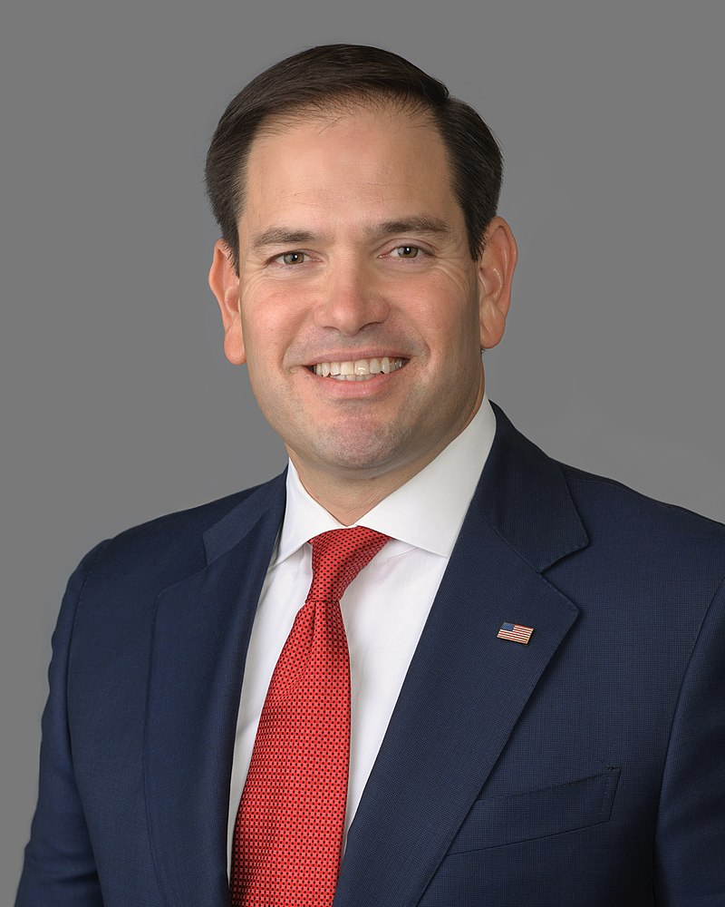

Figure 141 Portrait of Marco Rubio

Marco Antonio Rubio is a Republican and is the Senator for the state of Florida and has held his office since 2011. He has been part of the Republican party since as early as 1999. When we look at the analysis he tweeted the word ‘PPP’ more than any other word and this is explained by ‘Payback Protection Program’ which has been a great deal of public commentary. We can also see that words like ‘people’, ‘day’, and ‘need’. One interesting thing we can see is that Rubio doesn’t seem to mention the ‘president’ a lot which seems to have been different as compared to other republican leaders. When we look at his TextBlob analysis we can see that Marco tweets we can see his tweets have a Positive tweet rating of 44%(with 1329 Positive Tweets), a Negative tweet rating of 25%(760 Negative Tweets), and a Neutral tweet rating of 30%(912 Neutral Tweets). Based on the political analysis we performed Marco has a Polarity of 0.052749 and Subjectivity of 0.3617391. We can see the Polarity and Subjectivity plotted against each other in the figure below.

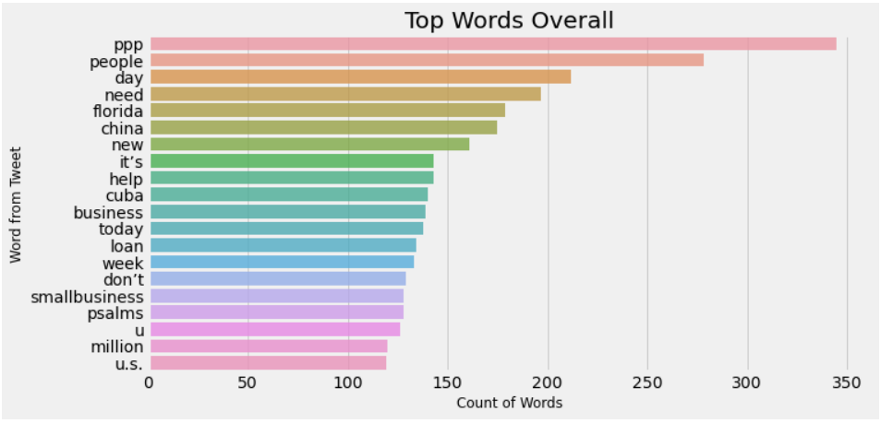

Figure 142 Top words used by Marco

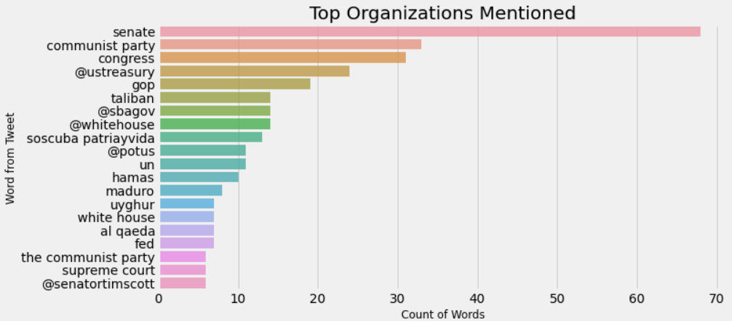

Figure 143 Top Organizations used for Marco

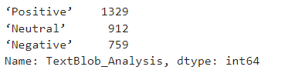

Figure 144 TextBlob analysis of Marco

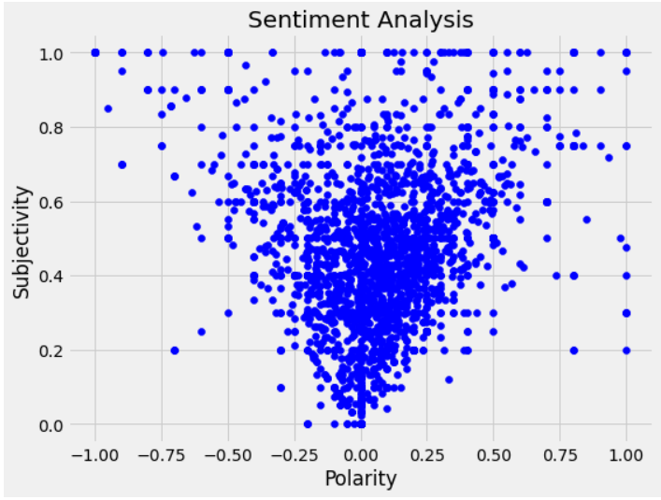

Figure 145 Sentiment Analysis of Marco

#### Rand Paul



Figure 146 Portrait of Rand Paul

Randal Howard Paul or commonly known as Rand Paul is a senator from the state of Kentucky and was holding this position since 2011. When we look at his Twitter data we can see that he uses the word ‘fauci’, which is explained as he constantly is at odds with the advice provided by Fauci. We can also see that the words like ‘great’, ‘war’ and ‘people’ a lot. When we look at his TextBlob analysis we can see that Rand tweets we can see his tweets have a Positive tweet rating of 46%(with 1368 Positive Tweets), a Negative tweet rating of 21%(616 Negative Tweets), and a Neutral tweet rating of 34%(1016 Neutral Tweets). Based on the political analysis we performed Rand has a Polarity of 0.095131 and Subjectivity of 0.3672488. We can see the Polarity and Subjectivity plotted against each other in the figure below.

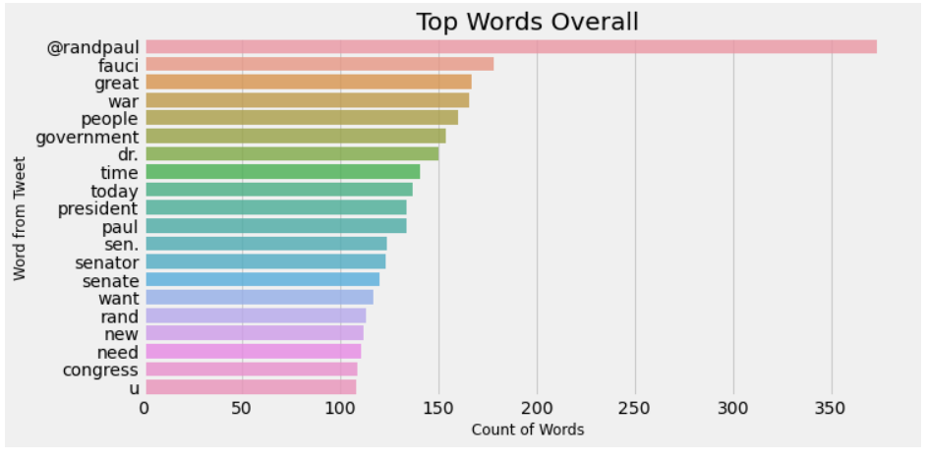

Figure 147 Top Words used by Rand

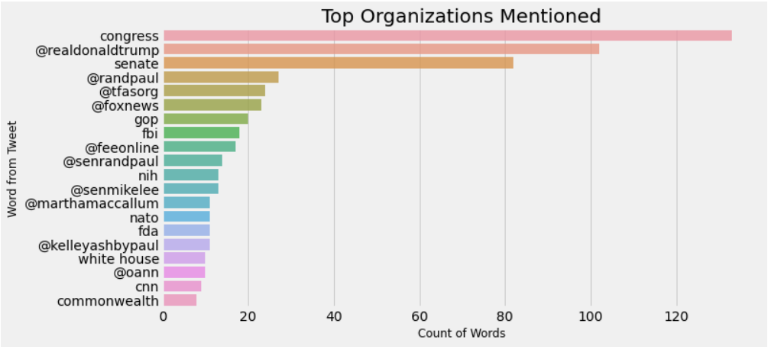

Figure 148 Top Organizations used by Rand

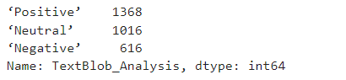

Figure 149 TextBlob Analysis of Rand

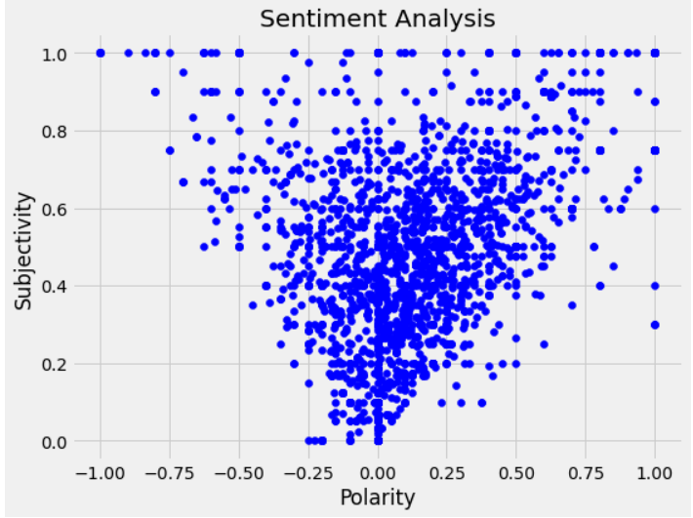

Figure 150 Sentiment Analysis of Rand

# 6 Conclusion And Future Work

## 6.1 Conclusion

Overall the goal of this project was to discover how weme can perform Sentiment Analysis on the Political Twitter data and see observe the results. On observing the results for the United Kingdom we can see some interesting analysis based on the candidates being observed we can see that Conservatives as a whole had a better sentiment analysis rating in all the metrics compared to the Labours, Conservatives had Positive tweets rating of 60% whereas the Labours only had 53%, this is a huge difference of 7%, it is the same story in all the other metrics as well. Torries had a Negative rating of 12.5% compared to Labour's 15%, while Neutral tweets of Torries were at 27%, it was 31% for the Labours. Even when we look at the Polarity and the Subjectivity Torries seem to outperform the Labours, while the Conservatives had 0.1696 and 0.4056 for both polarity and subjectivity respectively, the Labours had 0.135117 and 0.376426 and can know Torries seems to be outperforming the Labours.

When we look at the data from the United States we can see something different the Democrats lead in all the metrics when compared with the Republicans. The Dems had a positive tweets percentage of 54% while the Republicans only at 44% that’s a massive difference of 10% points, similar story with the Negative rating where Dems had a ranting of 17% while Republicans had one for 18% and Neutral tweet percentage of Dems was 30% while Republicans had one for 35%. Similar observation can be observed in the Polarity and Subjectivity as well, Dems had a polarity and subjectivity number of 0.1167 and 0.36556 while Republicans only had 0.09873 and 0.35388 on the similar metrics.

Looking at these numbers we can see an interesting pattern where the party which is in power right now is seemingly performing better in the sentiment analysis model. But when we look at their ideologies the results seem to be opposite, Labour being the left aligned party which can be compared to Democrats in the US as their party tends to swing left performed better on every single metric while Labours did worse in all of the possible metrics. Similarly, Torries being the right-wing alleged had performed better in all our models compared to the equivalent of Republicans in the United States. We can conclude that ideological differences alone won’t make a major difference in the sentiment analysis.

We can look at work from Ramasubbareddy Somula et al (2019) it showed how Trump was ahead in all the in sentimental analysis in most of the states which later turned out that he won. This perfectly aligns with our research where sentiment analysis usually tends to be positive towards the party that’s winning and doesn’t involve the political allegiance or which side of the political spectrum they belong to. This can be further seen from research from by Shah et al. (2021) where we can see the positive sentiment from Biden be shown when compared to Trump, which again proves the point of people supporting and having positive sentiment towards people in power or will be in power.

## 6.2 Future Work

Finally, when we look at the potential for future work we can increase the number of candidates taken from each party and increase the number of participant countries as well. Given the resources, this would provide a fascinating insight into how tweets are evaluated around the world and how they differ based on ideology. Given the restriction of the Twitter developer account having the responses of every tweet wasn’t possible, but given the access by some commercial third-party tool, we can explore in-depth how each tweet is being accepted by the public and gauge their reaction. This can provide fascinating results and an interesting study.

# References

About Britain, (2021) *Political parties in Britain - a short guide*. [online] About Britain . Available at: https://about-britain.com/institutions/political-parties.htm [Accessed 3 Jan. 2022].

Afaf Athar, (2021) *Textblob vs Vader For Sentiment Analysis in Python*. [online] Analytics Vidhya. Available at: https://www.analyticsvidhya.com/blog/2021/01/sentiment-analysis-vader-or-textblob/ [Accessed 18 Dec. 2021].

ALEX THOMPSON, (2020) *Why the right wing has a massive advantage on Facebook - POLITICO*. [online] Politico. Available at: https://www.politico.com/news/2020/09/26/facebook-conservatives-2020-421146 [Accessed 9 Nov. 2021].

Analytics India, (2020) *Sentiment Analysis Made Easy Using VADER*. [online] Analytics India. Available at: https://analyticsindiamag.com/sentiment-analysis-made-easy-using-vader/ [Accessed 18 Dec. 2021].

Andrew Rudalevige, (2017) *Why did the Founders make U.S. elections so complicated and confusing? Get your answers here. - The Washington Post*. [online] Washington Post. Available at: https://www.washingtonpost.com/news/monkey-cage/wp/2017/08/16/why-did-the-founders-make-u-s-elections-so-complicated-and-confusing-get-your-answers-here/ [Accessed 11 Nov. 2021].

Anon (2021) *Twitter Usage Statistics - Internet Live Stats*. [online] Available at: https://www.internetlivestats.com/twitter-statistics/ [Accessed 9 Nov. 2021].

Anon (2022) *Joe Biden: The President | The White House*. [online] Available at: https://www.whitehouse.gov/administration/president-biden/ [Accessed 9 Jan. 2022].

Anon (2022) *Sadiq Khan | London City Hall*. [online] Available at: https://www.london.gov.uk/people/mayoral/sadiq-khan [Accessed 9 Jan. 2022].

Anon (2022) *The most popular Labour politicians in the UK | Politics | YouGov Ratings*. [online] Available at: https://yougov.co.uk/ratings/politics/popularity/labour-politicians/all [Accessed 3 Jan. 2022].

Anon (2022) *The Rt Hon Michael Gove MP - GOV.UK*. [online] Available at: https://www.gov.uk/government/people/michael-gove [Accessed 2 Jan. 2022].

BBC, (2021) *Twitter’s algorithm favours right-leaning politics, research finds - BBC News*. [online] BBC. Available at: https://www.bbc.co.uk/news/technology-59011271 [Accessed 9 Nov. 2021].

BBC, (2022) *US political parties and their support - USA: Principles of government - Higher Modern Studies Revision - BBC Bitesize*. [online] Available at: https://www.bbc.co.uk/bitesize/guides/z2cy7p3/revision/6 [Accessed 9 Jan. 2022].

Bernard Enjolras, (2014) How politicians use Twitter and does it matter? The case of Norwegian national politicians. [online] Available at: https://www.researchgate.net/publication/260338229.

Bonta, V., Kumaresh, N. and Janardhan, N., (2019) *A Comprehensive Study on Lexicon Based Approaches for Sentiment Analysis*. [online] *Asian Journal of Computer Science and Technology*, Available at: www.rottentomatoes.

Budiharto, W. and Meiliana, M., (2018) Prediction and analysis of Indonesia Presidential election from Twitter using sentiment analysis. *Journal of Big Data*, 51.

Elghazaly, T., Mahmoud, A. and Hefny, H.A., (2016) Political Sentiment Analysis Using Twitter Data. [online] Available at: http://dx.doi.org/10.1145/2896387.

Financial Times, (2021) *Boris Johnson’s disregard for checks and balances | Financial Times*. [online] Financial Times. Available at: https://www.ft.com/content/bae8b105-1b53-4619-bcbd-41988cf07479 [Accessed 30 Dec. 2021].

GBMag, (2021) *How the British political system works - Great British Mag*. [online] GBMag. Available at: https://greatbritishmag.co.uk/uk-culture/how-the-british-political-system-works/ [Accessed 30 Dec. 2021].

Gov.UK, (2021a) *The Rt Hon Dominic Raab MP - GOV.UK*. [online] Gov.UK. Available at: https://www.gov.uk/government/people/dominic-raab [Accessed 31 Dec. 2021].

Gov.UK, (2021b) *The Rt Hon Elizabeth Truss MP - GOV.UK*. [online] Gov.UK. Available at: https://www.gov.uk/government/people/elizabeth-truss [Accessed 1 Jan. 2022].

Gov.UK, (2021c) *The Rt Hon Priti Patel MP - GOV.UK*. [online] Gov.UK. Available at: https://www.gov.uk/government/people/priti-patel [Accessed 1 Jan. 2022].

Hussein, D.M.E.D.M., (2018) A survey on sentiment analysis challenges. *Journal of King Saud University - Engineering Sciences*, 304, pp.330–338.

Hutto, C.J. and Gilbert, E., (2014) *VADER: A Parsimonious Rule-based Model for Sentiment Analysis of Social Media Text*. [online] Available at: http://sentic.net/.

Kartik Singhal, Basant Agrawal and Namita Mittal, (2015) Modeling Indian General Elections. In: *Information systems design and intelligent applications*.

Orhan G. Yalçın, (2020) *Sentiment Analysis in 10 Minutes with BERT and TensorFlow | by Orhan G. Yalçın | Medium | Towards Data Science*. [online] Towards Data Science. Available at: https://towardsdatascience.com/sentiment-analysis-in-10-minutes-with-bert-and-hugging-face-294e8a04b671 [Accessed 19 Dec. 2021].

Parthvi Shah, (2020) *Sentiment Analysis using TextBlob | by Parthvi Shah | Towards Data Science*. [online] Medium. Available at: https://towardsdatascience.com/my-absolute-go-to-for-sentiment-analysis-textblob-3ac3a11d524 [Accessed 17 Dec. 2021].

Paul David Webb, (2021) *Conservative Party | History, Facts, Policy, & Structure | Britannica*. [online] The Britannica. Available at: https://www.britannica.com/topic/Conservative-Party-political-party-United-Kingdom [Accessed 30 Dec. 2021].

Ramasubbareddy Somula, K. Dinesh Kumar, S. Aravindharamanan and K. Govinda, (2019) Twitter Sentiment Analysis Based on US Presidential Election 2016. *Smart Intelligent Computing and Applications*.

Richard Thomas, Allaina Kilby and Matthew Wall, (2020) *US Presidential debates: Do they matter? | Media@LSE*. [online] LSE. Available at: https://blogs.lse.ac.uk/medialse/2020/10/14/us-presidential-debates-do-they-matter/ [Accessed 11 Nov. 2021].

Rill, S., Reinel, D., Scheidt, J. and Zicari, R. v., (2014) PoliTwi: Early detection of emerging political topics on twitter and the impact on concept-level sentiment analysis. *Knowledge-Based Systems*, 691, pp.24–33.

Saraswati, M.S., (2018) Social Media and the Political Campaign Industry in Indonesia. *Jurnal Komunikasi Ikatan Sarjana Komunikasi Indonesia*, 31.

Shah, D. and Li, Y., (2021) Twitter Based Sentiment Analysis of Each Presidential Candidate Using Long Short-Term Memory. *Ahmad Hadaegh International Journal of Computer Science and Security (IJCSS)*, 15, p.87.

Shubham Jain, (2018) *NLP For Beginners | Text Classification Using TextBlob*. [online] Analytics Vidhya. Available at: https://www.analyticsvidhya.com/blog/2018/02/natural-language-processing-for-beginners-using-textblob/ [Accessed 9 Nov. 2021].

Sprenger, T.O., Tumasjan, A., Sandner, P.G. and Welpe, I.M., (2014) Tweets and Trades: The Information Content of Stock Microblogs. *European Financial Management*, [online] 205, pp.926–957. Available at: https://papers.ssrn.com/abstract=2517025 [Accessed 17 Nov. 2021].

Statista, (2021) *• Twitter: most users by country | Statista*. [online] Available at: https://www.statista.com/statistics/242606/number-of-active-twitter-users-in-selected-countries/ [Accessed 10 Nov. 2021].

Wang, H., Can, D., Kazemzadeh, A., Bar, F. and Narayanan, S., (2012) *A System for Real-time Twitter Sentiment Analysis of 2012 U.S. Presidential Election Cycle*. [online] Association for Computational Linguistics. Available at: http://t.co/qEns1Pmi.